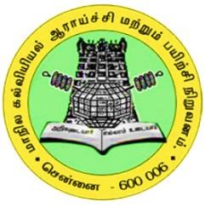

DISTRICT INSTITUTE OF EDUCATION AND TRAINING RANIPET

“Enhancing the understanding of DNA structure through Multimedia Package for 10th
standard students in GHSS, Pootuthakku, Arcot Block”

ACTION RESEARCH REPORT 2024 - 2025

RESEARCHER

Miss. S. ARUMBUMOZHI, M.Sc., M.Phil., M.Ed., LECTURER
DIET, RANIPET

SUBMITTED TO
STATE COUNCIL OF EDUCATIONAL RESEARCH AND TRAINING CHENNAI – 06

- INTRODUCTION

"Enhancing the understanding of DNA structure through a Multimedia Package for 10th standard students" addresses a critical pedagogical challenge in science education. The abstract nature of molecular biology, particularly the structure and function of DNA, often presents a significant hurdle for secondary school students. Traditional teaching methods, relying heavily on static diagrams and textual descriptions, may fail to fully convey the dynamic and three- dimensional aspects of this crucial biomolecule.
This initiative aligns with contemporary research in science education that emphasizes the benefits of incorporating multimedia resources to improve student engagement, conceptual understanding, and long-term retention. By developing and evaluating a multimedia package tailored to the specific learning needs of 10th standard students, this project offers an opportunity to investigate the efficacy of various multimedia elements – such as interactive 3D models, animations, and simulations – in demystifying complex biological concepts.
Our senses are the gateways through which we acquire knowledge about our surroundings. Just as there are many differences among people in their appearance, thoughts, and actions, similarly, these senses and the ways they function also differ. Learning through the senses establishes clear and lasting knowledge. It is the brain's function to select, categorize, modify, and connect all experiences gained through the senses, transforming them into general concepts and knowledge. Thus, the foundation for the emergence of various thoughts that stimulate our understanding of the world lies in the experiences gained through our senses.
Furthermore, this research can contribute valuable insights into the design principles of effective educational multimedia for science learning. By assessing the impact of the package on student learning outcomes, attitudes towards science, and the development of spatial reasoning skills, this work has the potential to inform future curriculum development and the creation of innovative teaching resources in molecular biology and beyond. The findings could also highlight the importance of considering cognitive load and the appropriate scaffolding of information when designing multimedia learning experiences for adolescent learners. Ultimately, this research endeavors to contribute to the evidence-based development of more engaging and effective strategies for teaching fundamental concepts in biology, thereby fostering a stronger foundation for future scientific inquiry.

- BACKGROUND OF THE ACTION RESEARCH
Information and Communication Technology (ICT) has emerged as a powerful tool in enhancing educational outcomes, particularly in science education. ICT provides interactive, visual, and experiential learning experiences that can make abstract concepts more tangible. Especially, through ICT, complex biological processes like DNA replication and transcription will be broken down into step-by-step animations, making it easier for students to understand intricate details. This interactive tools also helps students to manipulate DNA models. The level of understanding of the students was found to be low in the concept DNA structure. Therefore, this research is considered necessary to improve the understanding of this subject and increase the learning effect of the students.

- IDENTIFICATION OF THE PROBLEM

Information technology-enabled learning plays a major role in carrying out teaching and learning activities not only during pandemics but also at all times. DNA is a fundamental theme for subjects such as genetics, genetic engineering, biotechnology, molecular biology in science. While going to school visit the Researcher observed the Ranipet District, the level of understanding of the concept of DNA structure in the Genetics section of the 10th standard science subject was found to be low. Therefore, this action research is considered necessary to improve the understanding of this concept and increase the learning outcome.

- NEED FOR ACTION RESEARCH

While going to school visit the Researcher, observed the conceptual understanding of the students in DNS Structure topic of Xth standard in GHSS, Pootuthakku, Arcot block. The students are not able to understand the concept. Simply the students are doing the book back activities without understanding the concept. The students are not interest in studying the DNA concepts. And the teachers are also skipto taught the concept, because it is not included in the blue print for public examination question paper. The students must understand the purpose of the textbook concept was prepared. To make the teachers and students understand the DNA structure concept given in the Science textbook through Multi-Media Packages. Then the researcher planned to do this area for this action research. Through Multi-Media Package the students are able to understand this concept.
- They are able to understand the concept.
- They are able to know the sequence of the concept.
- They are recognizing the importance of concept.

The Investigator felt that the students did not have adequate experiences in terms of recognizing, analyzing and finding the understanding in relevant to the topic. So, the researcher decided to make the students to reflect on what they have understood would improve their observation skills and make them a successor of future perspectives. Hence, the Investigator has chosen this topic for the study.

STATEMENT OF THE PROBLEM
This study seeks to address the problem of limited understanding of DNA structure by investigating how the use of multi-Media package-based teaching methods can enhance students' conceptual grasp, engagement, and academic performance in this area of biology. The research will also evaluate the challenges teachers face in adopting multi-Media package and explore best practices for integrating technology into the curriculum effectively.

OBJECTIVES OF THE ACTION RESEARCH
- To find out the level of understanding of the concept of DNA through pre-test.
- To identify the reason why the level of understanding of the concept of DNA is found to be low.
- To enhance the understanding of the concept of DNA through Information Technology.
- To find out the level of understanding of the concept of DNA through post-test.

PROBABLE CAUSES FOR THE PROBLEM
- They prefer Traditional teaching methods.
- Lack of knowledge to integrate the ICT with our subject.
- Limited ICT experts

- Lack of Teacher Training based on ICT.

- Lack of biology teachers in school

- Students are varying levels of access in ICT devices.

- Lack of basic knowledge about Biology concepts.

- Lack of time to use the ICT.

- Board exam stress.

ACTION HYPOTHESIS
- If 10th standard students engage with a multimedia package designed to teach DNA structure, then they will demonstrate a deeper understanding of key concepts such as the double helix, nucleotide components, and base pairing rules.

METHODOLOGY

- Sample: Under the Tamil Nadu State, Ranipet District, Arcot block, 10th standard 30 students (3 male, 27 female) studying at Government Higher Secondary School, Pootuthakku were selected as the sample for this study.

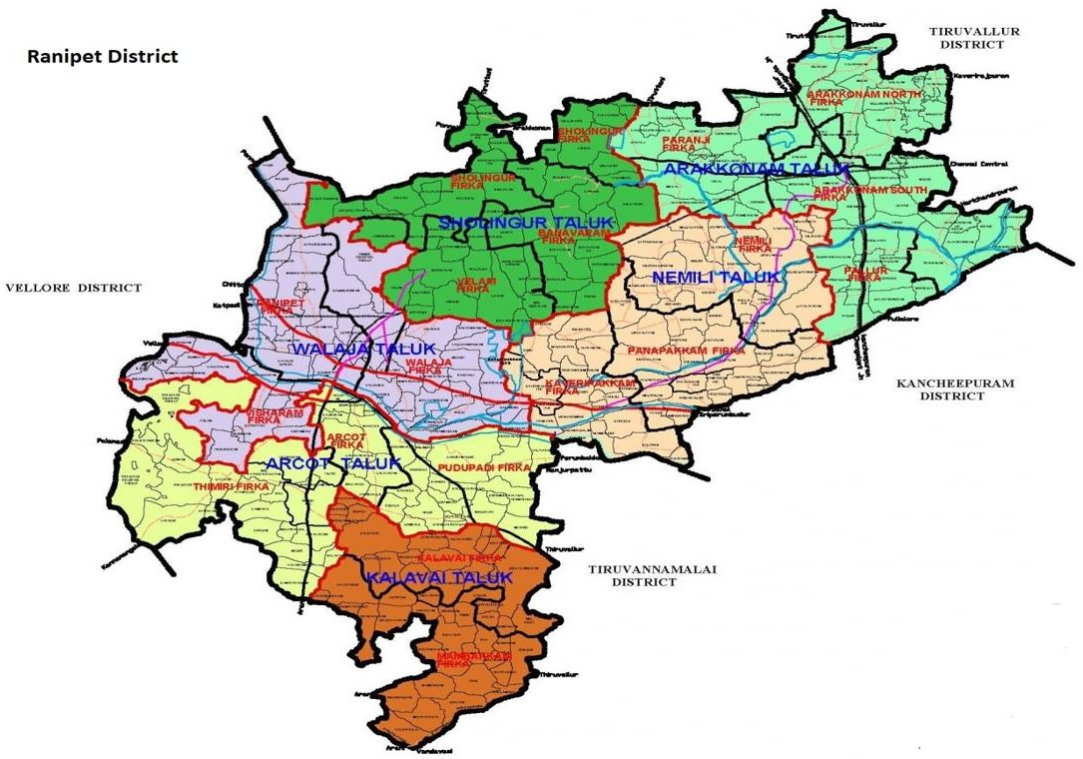

- Research Design: One-group pre-test and post-test experimental design.

- Description of the Research Tool: DNA Structure Achievement Test Questionnaire (30 marks) - (Based on the model of the National Achievement Survey question paper and NEET examination question paper).
- Description of the Research Process: In accordance with the objectives of the field study, a pre-test was administered to 10th standard students, followed by the implementation of implementation strategies, and finally conducted a post-test.

- Data Collection: Statistical analysis was conducted on the data collected from the pre-test and post-test to prepare the research report.

- Intervention:
The following strategies are followed by the researcher.
- Downloaded videos
DNA structure
DNA- chemical composition
DNA Model Drawing
DNA- model Making
(2) Power point prepared by the researcher
(3) Videos prepared by the researcher

- Downloaded videos - DNA structure
https://youtu.be/uolqoLVV3s4
- DNA- chemical composition
https://youtu.be/2CURBMcLBtc
- DNA Model Drawing
https://www.youtube.com/shorts/xH8AN3iDzos?feature=share
https://www.youtube.com/shorts/lS1fqTZmBTA?feature=share
- DNA Model Making

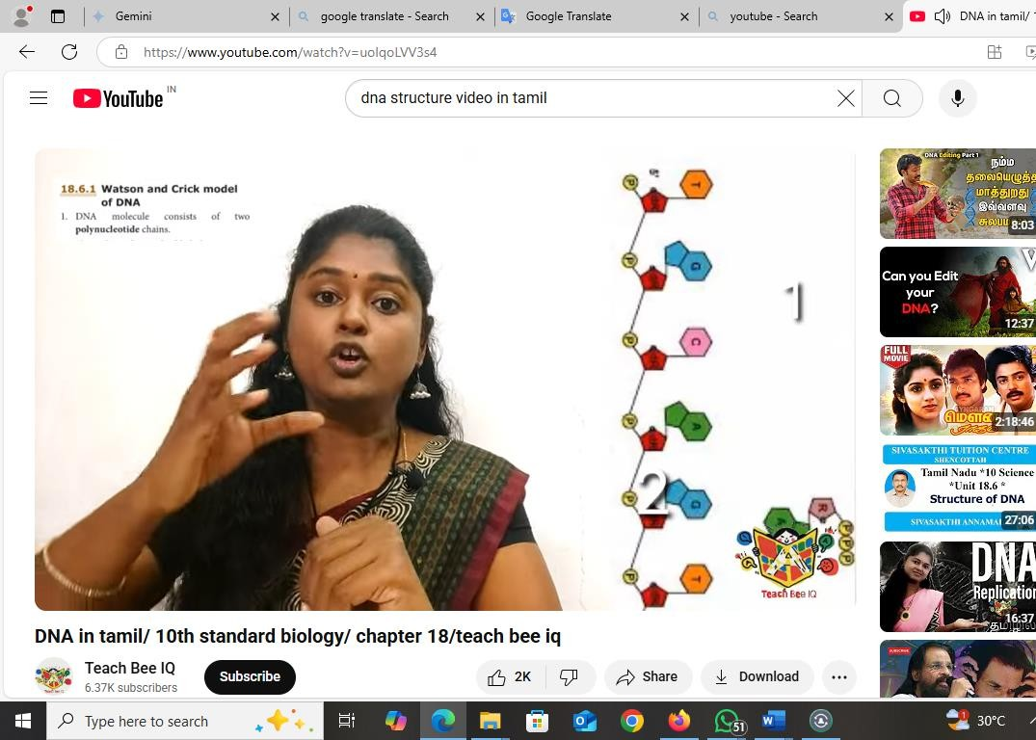
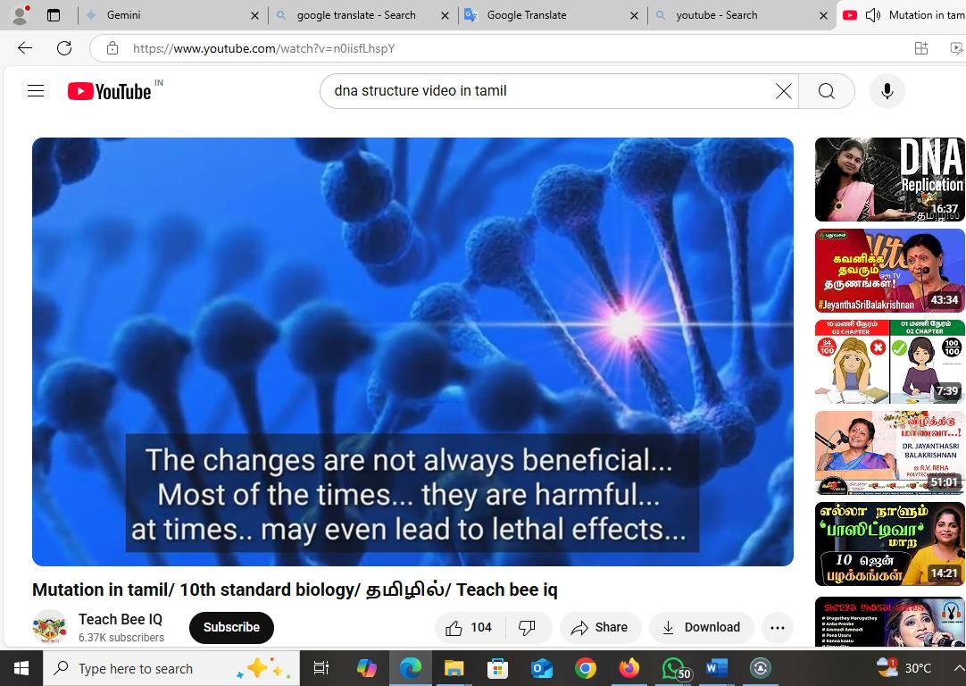
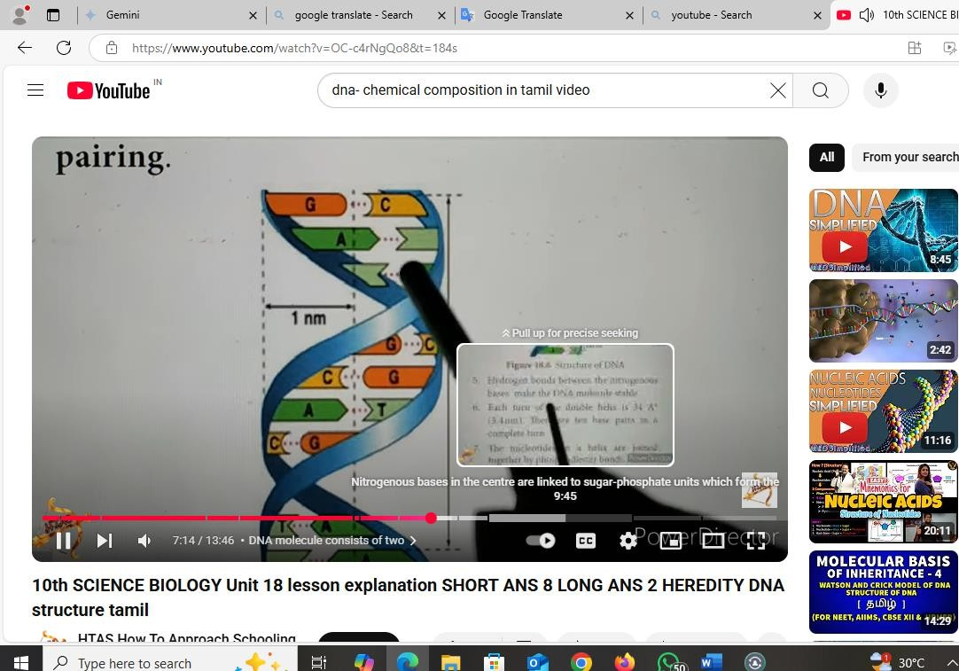
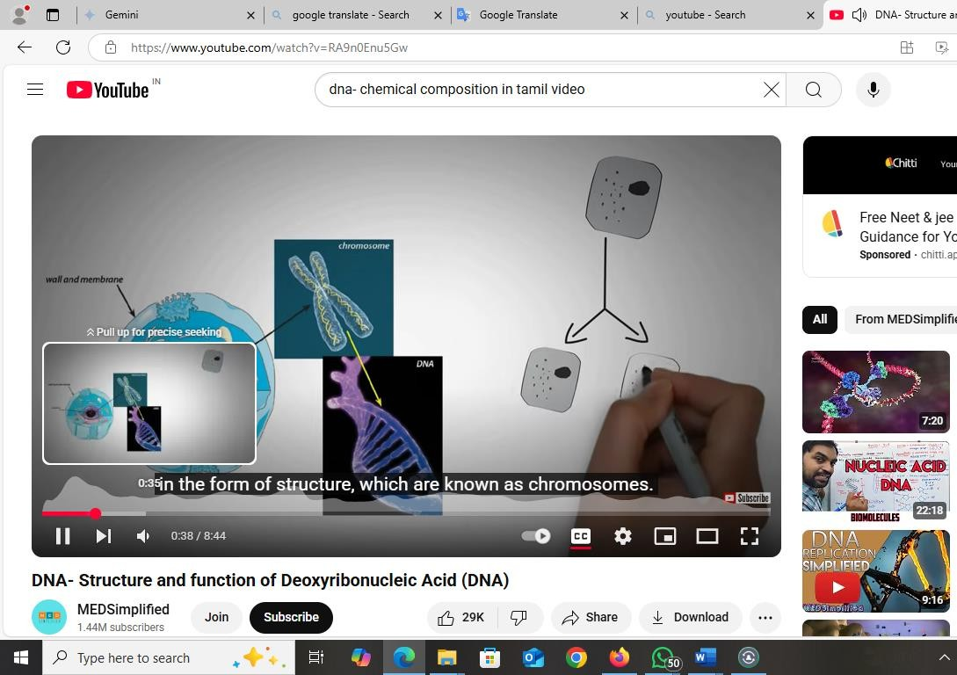
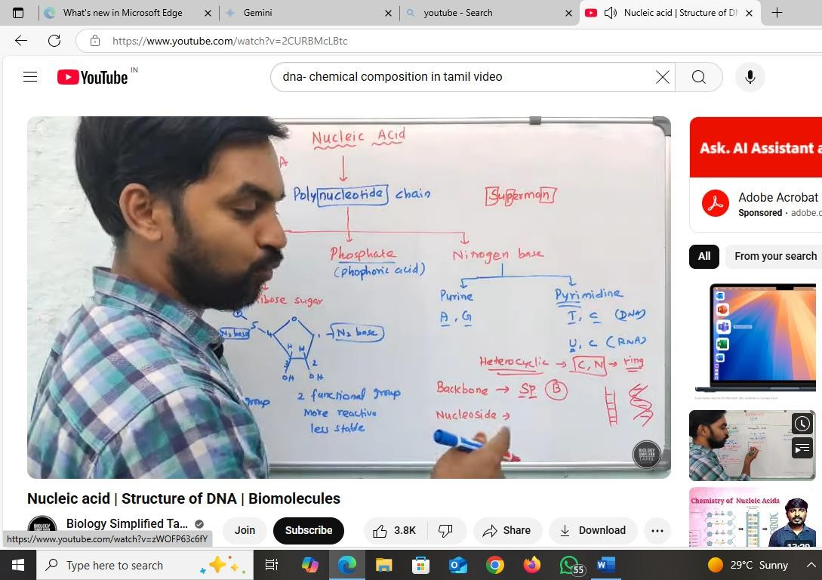
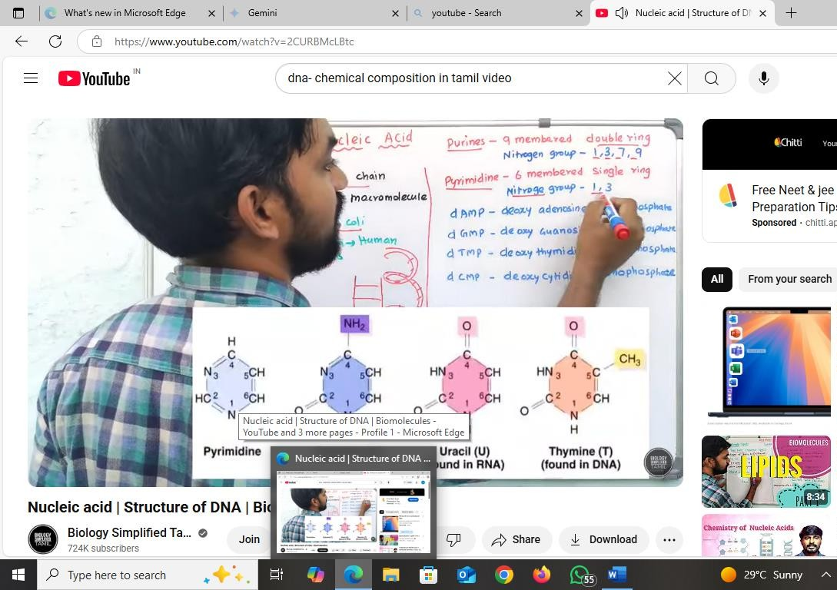
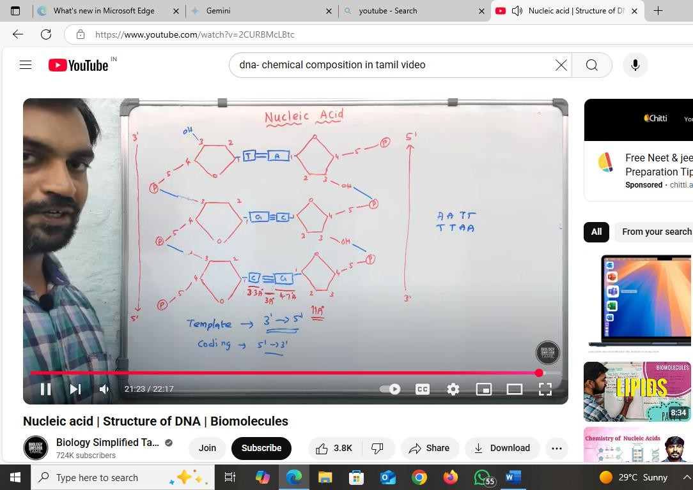
DNA Model Drawing
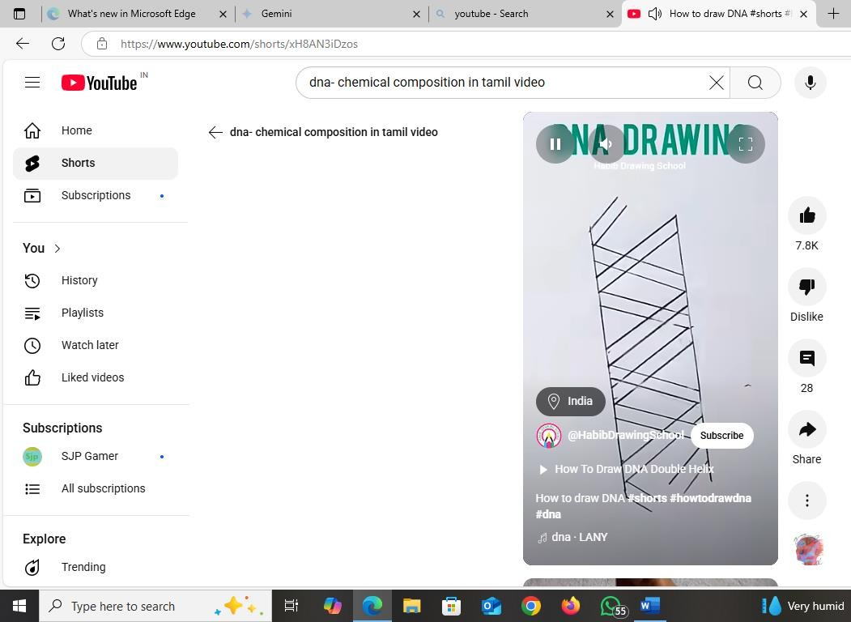
DNA- Model Making

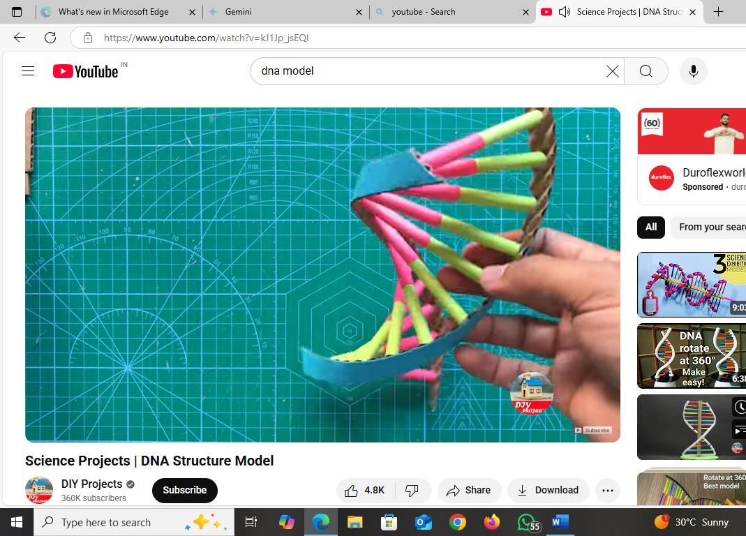
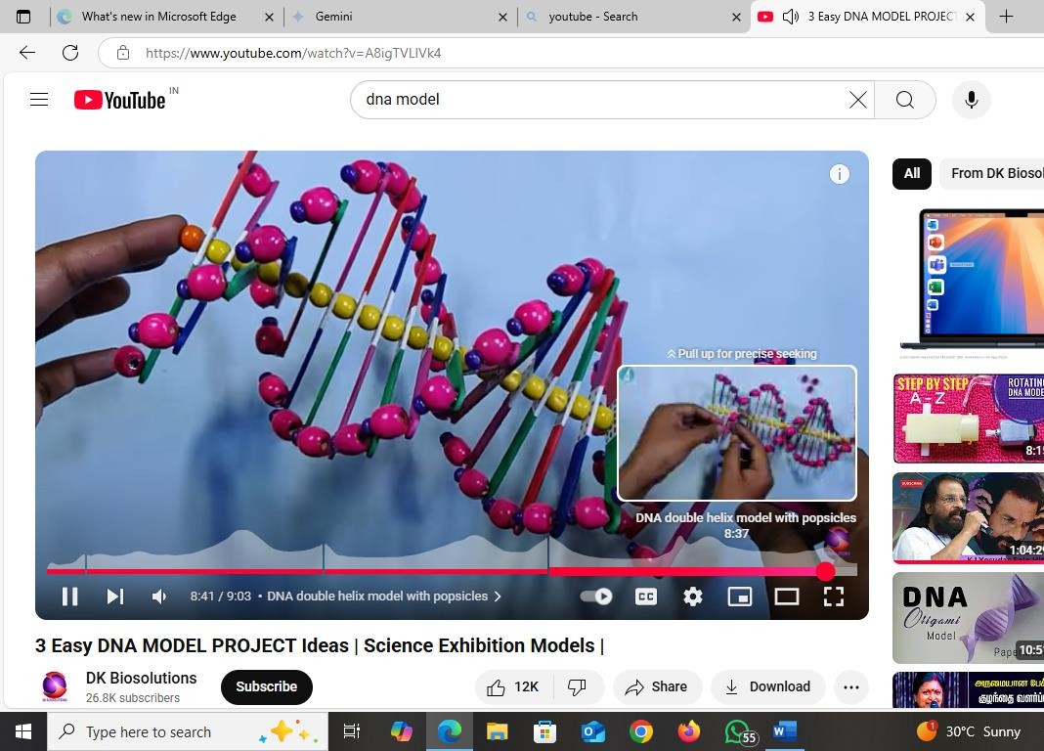
Power point
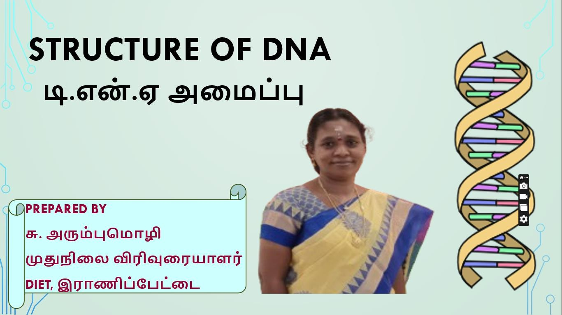
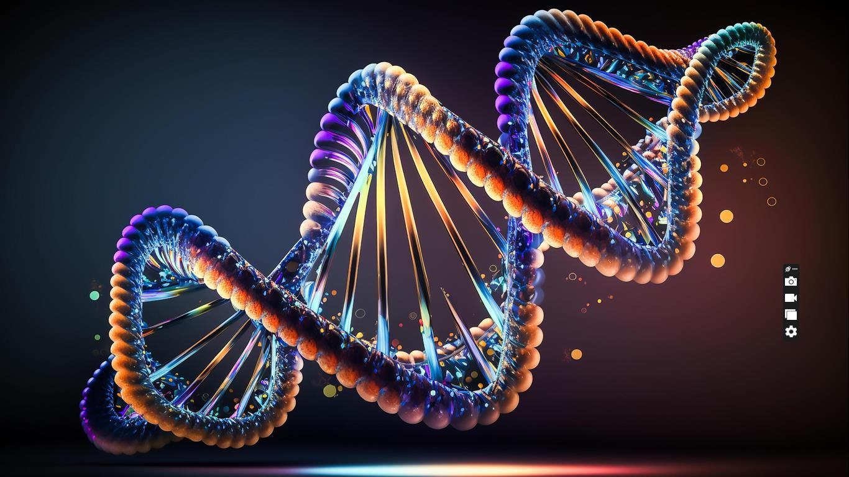
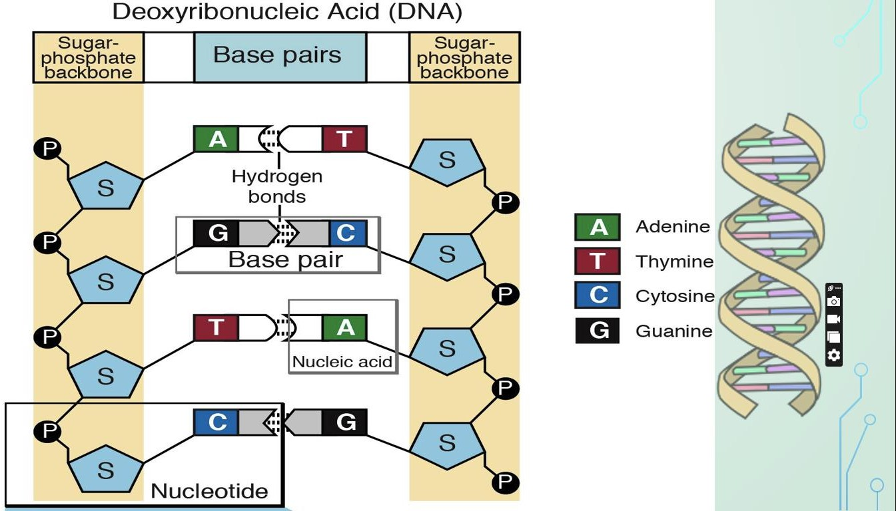
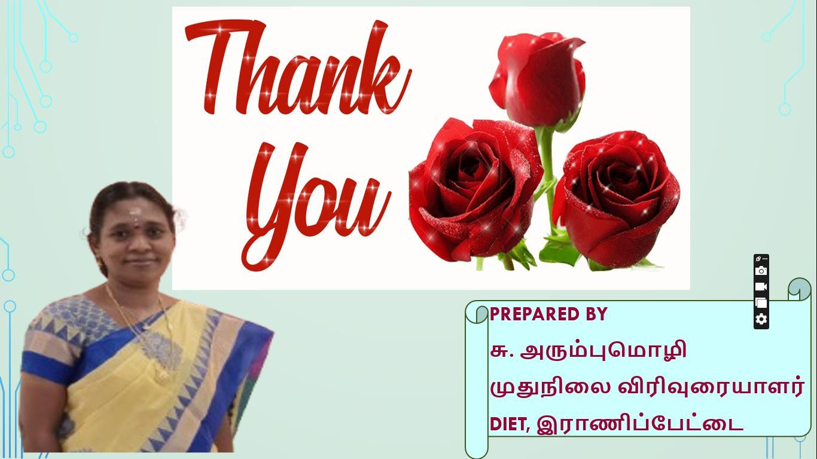
Videos prepared by the researcher

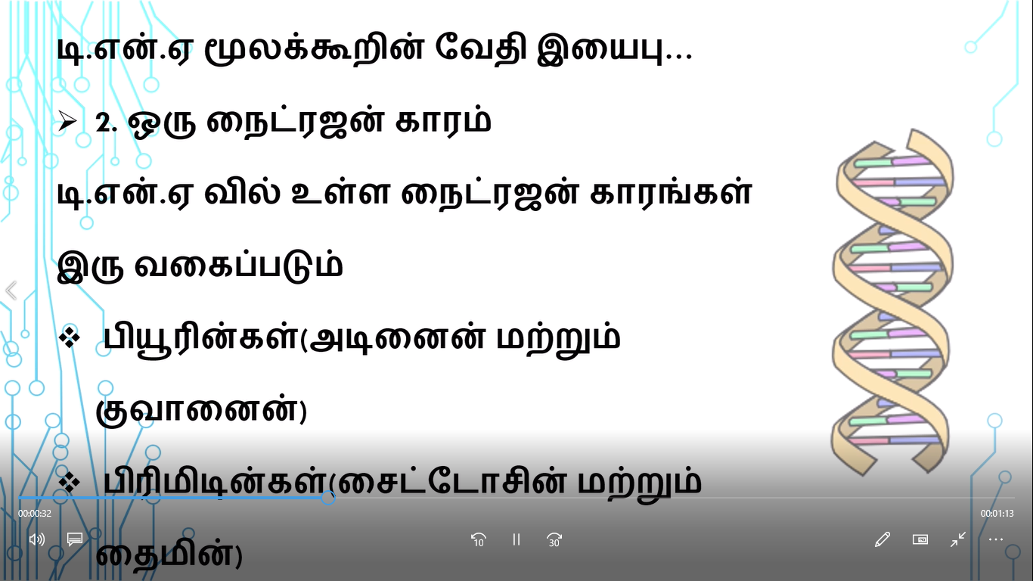
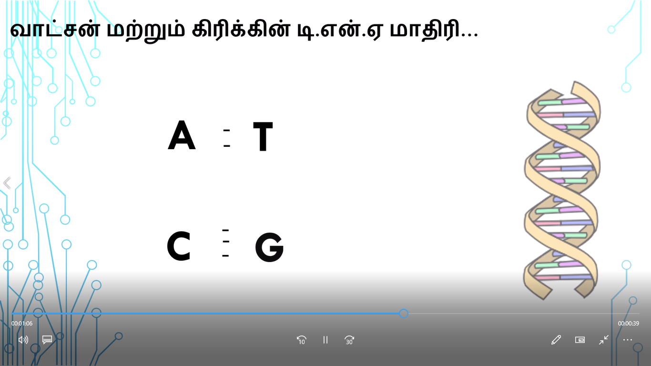

Data Analysis
In the action research titled “Enhancing the understanding of DNA structure through Multimedia Package for 10th standard students in GHSS, Pootuthakku, Arcot Block.” The following statistical analysis methods were employed based on the pre-test and post-test scores of the students to determine the research findings.
- Mean

- Percentage

ANALYSIS AND INTERPRETATIONS
  - STUDENTS LIST

S. No | Name of the Student | Gender
1 | CHITHRA B | FEMALE
2 | DHANUSHKA B | FEMALE
3 | DHARSHINI A | FEMALE
4 | DHARSHINI S | FEMALE
5 | DHARSHINI V | FEMALE
6 | HAFFIYA S | FEMALE
7 | HARIPRIYA S | FEMALE
8 | JEEVITHA J | FEMALE
9 | JEEVITHA K | FEMALE
10 | KALAIYARASI K | FEMALE
11 | KAVIYA S | FEMALE
12 | LOGAMITHRA P | FEMALE
13 | MADHU MITHA S | FEMALE
14 | MONISHA SREEVINI R | FEMALE
15 | MYTHILI D | FEMALE
16 | NARMADHA K | FEMALE
17 | PRAVEENA K | FEMALE
18 | PREMA G | FEMALE
19 | SADHANA V | FEMALE
20 | SANGEETHA B | FEMALE
21 | SARANYA M | FEMALE
22 | SHIVANI M | FEMALE
23 | SRINIDHI J | FEMALE
24 | SUJATHA K | FEMALE
25 | TAMIL SELVI K | FEMALE
26 | TEJA SREE D | FEMALE
27 | VISHNU PRIYANKA V | FEMALE
28 | GOKULRAJ S | MALE
29 | THIRUKUMARAN G | MALE
30 | SANDEEP DHARSHAN K | MALE

  - STUDENT SECURING PRE-TEST SCORE:

S. No | Name of the Student | Pre-Test 30 Marks
1 | CHITHRA B | 23
2 | DHANUSHKA B | 17
3 | DHARSHINI A | 15
4 | DHARSHINI S | 12
5 | DHARSHINI V | 13
6 | HAFFIYA S | 16
7 | HARIPRIYA S | 22
8 | JEEVITHA J | 29
9 | JEEVITHA K | 25
10 | KALAIYARASI K | 17
11 | KAVIYA S | 21
12 | LOGAMITHRA P | 18
13 | MADHU MITHA S | 22
14 | MONISHA SREEVINI R | 16
15 | MYTHILI D | 25
16 | NARMADHA K | 21
17 | PRAVEENA K | 20
18 | PREMA G | 15
19 | SADHANA V | 18
20 | SANGEETHA B | 13
21 | SARANYA M | 12
22 | SHIVANI M | 17
23 | SRINIDHI J | 15
24 | SUJATHA K | 20
25 | TAMIL SELVI K | 23
26 | TEJA SREE D | 20
27 | VISHNU PRIYANKA V | 14
28 | GOKULRAJ S | 20
29 | THIRUKUMARAN G | 17
30 | SANDEEP DHARSHAN K | 13

  - STUDENT SECURING POST-TEST SCORE:

S. No | Name of the Student | Pre-Test 30 Marks
1 | CHITHRA B | 27
2 | DHANUSHKA B | 23
3 | DHARSHINI A | 20
4 | DHARSHINI S | 25
5 | DHARSHINI V | 21
6 | HAFFIYA S | 20
7 | HARIPRIYA S | 28
8 | JEEVITHA J | 27
9 | JEEVITHA K | 28
10 | KALAIYARASI K | 21
11 | KAVIYA S | 26
12 | LOGAMITHRA P | 24
13 | MADHU MITHA S | 27
14 | MONISHA SREEVINI R | 20
15 | MYTHILI D | 28
16 | NARMADHA K | 23
17 | PRAVEENA K | 22
18 | PREMA G | 19
19 | SADHANA V | 23
20 | SANGEETHA B | 18
21 | SARANYA M | 17
22 | SHIVANI M | 23
23 | SRINIDHI J | 20
24 | SUJATHA K | 25
25 | TAMIL SELVI K | 27
26 | TEJA SREE D | 24
27 | VISHNU PRIYANKA V | 18
28 | GOKULRAJ S | 24
29 | THIRUKUMARAN G | 19
30 | SANDEEP DHARSHAN K | 20

  - Mean and Percentage Scores:

Test | No. of. Student | Score | Average | Percentage | Difference in Percentage
Pre-Test | 30 | 394 | 13.13 | 39.4% | 29.3%
Post-Test | 30 | 687 | 22.9 | 68.7% | 29.3%

According to the table shown above, the average score of students in the pre- test has increased from 13.13 to an average score of 22.9 in the post-test.
When comparing the scores obtained by the students in these two tests, it can be seen that the students achieved 29.3% more in the post-test than in the pre-test. Therefore, it is evident that the students have gained an understanding of "DNA Structure."
  - Bar Diagram of Mean Score Comparison of Students' Pre-test and Post-test.
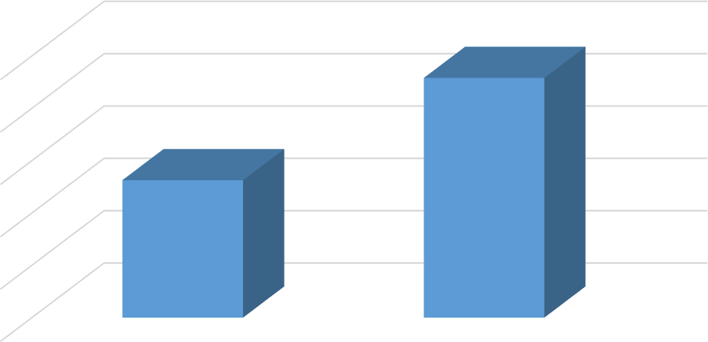
Average
25

20

15
22.9
10
13.13
5

0
Pre-Test
Post-Test

  - Pie Diagram of Percentage Comparison of Students' Pre-test and Post-test Scores.

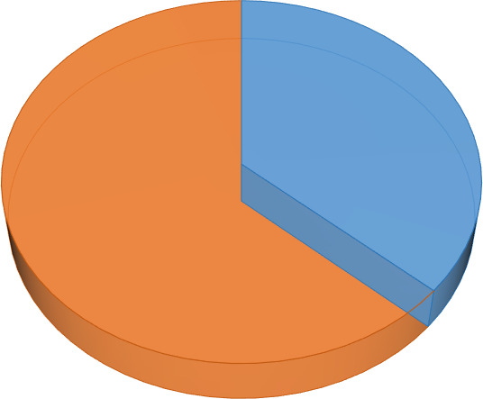
PERCENTAGE
Post-Test,
68.70%
Pre-Test, 39.40%

FINDINGS OF THE ACTION RESEARCH

- The students have gained an understanding and explanation of "DNA Structure."

- The pre-test percentage of students' understanding of "DNA Structure" is 39.40%.

- The reasons for the low level of understanding of the lesson concept "DNA Structure" include the incomprehensibility of the chemical structure, chemical names, the replication process, and its events.
- The post-test percentage of 68.70% demonstrates an improvement in the level of understanding of the lesson concept "DNA Structure" through multi-Media package.

NET GAIN OF THE ACTION RESEARCH

The result is the 29.3% difference between the pre-test and post-test. This gain strongly supports the effectiveness of the intervention. It implies that students acquired a significantly higher level of knowledge or proficiency, moving from a basic understanding to a more competent level. These results underscore the success of the implemented educational approach.

EDUCATIONAL IMPLECATIONS OF ACTION RESEARCH

In science, DNA is a fundamental concept for subjects like genetics, genetic engineering, biotechnology, and molecular biology. Furthermore, when lessons are taught through information technology like this to face achievement tests, competitive exams, and aptitude tests, additional understanding skills develop, and interest increases. As a result, students learn without any hesitation and actively participate in teaching and learning activities, working in collaboration with science and technology to achieve their educational goals. Teachers also qualify themselves according to the growing technological advancements.

RECOMMENDATIONS

The curriculum should be designed to move from concrete to abstract, incorporating various learning styles through multimedia. And the curriculum should explicitly state where and how multimedia will be used like Interactive 3D Models/Simulations.

The curriculum should incorporate with the Real-world Connections like Video Clips or Case Studies on forensic science (DNA fingerprinting), genetic disorders (very basic introduction to mutations), or biotechnology. It creates interest among students on this concept.

The following trainings should be given for the teachers

a. Introduction about Basic computer technological skills.

b. Effective implementation on multimedia package.

c. Proper usage of interactive whiteboards or smartboards.

CONCLUSION

With the aim of enhancing students' learning outcomes, transforming social media such as television, computers, laptops, and mobile phones into information technology tools that support teaching and learning—like educational television, laptop-video lessons, and mobile applications—increases the level of understanding of lessons. This not only improves current achievement but also helps lay a strong foundation for future education.

BIBLIOGRAPHY

- Action Research - Introduction - State Council of Educational Research and Training (SCERT), Chennai.
- 10th Standard Science Textbook - Tamil Nadu Textbook Corporation, Chennai.

- Facilitating and Enhancing Learning - Teacher Education Source book.

Annexture – 1 RESEARCH TOOL

மாவட்ட ஆசிரியர் கல்வி மற்றும் பயிற்சி நிறுவனம்
இராணிப்பேட்டை மாவட்டம்.
செயலாராய்ச்சி முன்தேர்வு வினாத்தாள் (பத்தாம் வகுப்பு)

மாணவர் பெயர் :
பிரிவு :
பாலினம் : ஆண் / பெண்
பள்ளியின் பெயர் மற்றும் முகவரி: அரசு மேல்நிலைப் பள்ளி, பூட்டுதாக்கு.
மொத்த மதிப்பெண்:30
அனைத்து வினாக்களுக்கும் விடையளி: சரியான விடையை வட்டமிடுக.
1. மனித / தாவர உட்கருவில் காணப்படும் மெல்லிய நூல் போன்ற அமைப்பிற்கு _______ என்று பெயர் .
அ. எண்டோபிளாச வலை ஆ .வாக்குவோல்கள்
இ .குரோமோசோம் ஈ .லைசொசோம்
2. டி.என்.ஏ வின் விரிவாக்கம்
அ . டீ ஆக்ஸி ரைபோ நியூக்ளியஸ் ஆ .டிரை ஆக்ஸி ரைபோ நியூக்ளிக் அமிலம் ,
இ . டை ஆக்ஸிஜன் ரைபோ நியூக்ளியஸ் ஈ . டீ ஆக்ஸி ரைபோ நியூக்ளிக் அமிலம்
3. டி.என்.ஏ வின் முப்பரிமாண மாதிரியை வெளியிட்டவர்கள்:
அ . வாட்சன் & பிராங்க்ளின் ஆ. வாட்சன் & க்ரிக்
இ . ஜேம்ஸ் வாட்சன் & வில்கின்ஸ், ஈ . பிராங்க்ளின் & வில்கின்ஸ்
4. டி.என்.ஏ வில் உள்ள நைட்ரஜன் காரங்களில் ப்ரிமிடின்கள் என்பவை
அ. அடினைன் & குவானைன் ஆ . அடினைன் & சைடோசின்
இ.சைடோசின் & தைமின் ஈ. குவானைன்& தைமின்
5. டி.என்.ஏ மூலக்கூறு ________என அழைக்கப்படுகிறது
அ . ப்யூரின்கள் ஆ .ப்ரிமிடின்கள்
இ . பாலி நியூகிளியோடைடு ஈ . பாலி நியூகிளியோசைடு

6. டி.என்.ஏ இரட்டைச் சுருள் அமைப்பின் ஒவ்வொரு சுற்றும் _______ அளவிலானது.
அ .33 Aº ஆ 34 Aº
இ 43 Aº ஈ 3.4 mm
7. நைட்ரஜன் காரங்கள் எந்த பிணைப்பில் இணைக்கப்பட்டுள்ளது ?
அ.நைட்ரஜன் ஆ . ஹைட்ரஜன்
இ . சர்க்கரை ஈ . பாஸ்பேட்
8. மரபியல் தகவல்களை ஒரு தலைமுறையில் இருந்து அடுத்த தலைமுறைக்கு கடத்துவது ____ ஆகும் .
அ. டி.என்.ஏ ஆ . குரோமோசோம்
இ . ஆர் .என்.ஏ ஈ . .எம் ஆர் .என்.ஏ
9. சைடோசின் குவானைனுடன் எத்தனை பிணைப்புகளால் இணைக்கப்பட்டுள்ளது?
அ.ஒன்று ஆ . இரண்டு
இ . மூன்று ஈ நான்கு
10. டி. என்.ஏ இரட்டிப்பாதல் நிகழ்வில் தொடர்பில்லாத ஒன்று ._____
அ.ஹெலிகேஸ் ஆ . பாலிமரேஸ்
இ . லோகஸ் ஈ. லிகேஸ்
11. ஒவ்வொரு செல்லின் முதுமையை உணர்த்தும் கடிகாரங்கள் இவை
அ. சென்ட்ரோமியர் ஆ . டீலோமியர்
இ . பெல்லிக்கில் ஈ . குரோமேடிட்
12. குரோமோசோம் கட்டமைப்பிற்கு ஆதாரமாக விளங்கும் புரதங்கள்
அ. ஹிஸ்டோன் ஆ. மெலட்டோனின்
இ. லிகேஸ் ஈ. பாலிமரேஸ்
13. 1962 இல் மருத்துவத்திற்கான நோபல் பரிசு எந்த கண்டுபிடிப்பிற்காக வழங்கப்பட்டது?
அ. குரோமோசோம் ஆ. உட்கரு
இ. நியுக்ளிக் அமில மூலக்கூறு அமைப்பு ஈ.செல்
14. டி. என்.ஏ வில் எப்பொழுதும் அடினைன் விகிதமும் தைமின் விகிதமும் சமமாக இருக்கும் . இது எந்த விதி ?
அ. சார்பின்றி ஒதுங்குதல் விதி ஆ. தனித்து பிரிதல் விதி
இ . சார்காப் விதி ஈ. ஓங்கு தன்மை விதி
15. ஒரு நியுக்ளியோடைடு என்பது __________
அ. சர்க்கரை மூலக்கூறுகள் ஆ. நைட்ரோஜன் காரம்
இ . பாஸ்பேட் தொகுதி ஈ . இவை அனைத்தும்
16. சில குரோமோசோம்களின் ஒரு முனையில் காணப்படும் நீண்ட குமிழ் போன்ற இணையுறுப்புக்கு _______ என்று பெயர்.
அ. உட்கரு மணி ஆ. குரோமோடிட்
இ . பெல்லிகில் ஈ .சாட்டிலைட்

17. ஒவ்வொரு மனித செல்லிலும் பொதுவாக _______ ஜோடி குரோமோசோம்கள் காணப்படும்.
அ. 22 ஆ. 23
இ . 24 ஈ. 25
18. குரோமோசோம்களின் எண்ணிக்கை, அளவு, மற்றும் வடிவம் ஆகியவை பற்றிய வரைபட விளக்கத்தை ________ என அழைப்பர்
அ. மோனோகிராம் ஆ.ஹெடிரோ கிராம்
இ .இடியோகிராம் ஈ . அல்லோ கிராம்
19. ஓர் உயிரியின் பாலினத்தை நிர்ணயிக்கின்ற குரோமோசோம்களை ________ என அழைக்கப்படுவது இல்லை
அ . அல்லோசோம்கள் ஆ .ஆட்டோசோம்கள்
இ. பால்குரோமோசோம்கள் ஈ .ஹெட்டிரோசோம்கள்
20. டி. என்.ஏ இரட்டிப்பாதல் தொடங்கும் இடத்தில் _______ என்ற நொதி இணைகிறது.
அ. லிகேஸ் ஆ . ஹெலிகஸ்
இ. பாலிமரேஸ் ஈ. ஐசொமொரேஸ்
பொருத்துக ( 21-25)
அ | ஆ
21. நியூகிளியோசைடு | A. சர்க்கரை +பாஸ்பேட் தொகுதிகள்
22. ப்யூரின்கள் | B. நைட்ரஜன் + சர்க்கரை
23. டி.என்.ஏ வின் முதுகெலும்பு | C. ஒகசாகி துண்டுகள்
24. சார்காப் விதி | D. அடினைன் =தைமின்
25. டி.என்.ஏ வின் சிறிய பகுதி | E. அடினைன் மற்றும் குவனைன்

கீழ்க்காணும் படத்தில் கோடிட்ட இடத்தை நிரப்புக : (26-30)
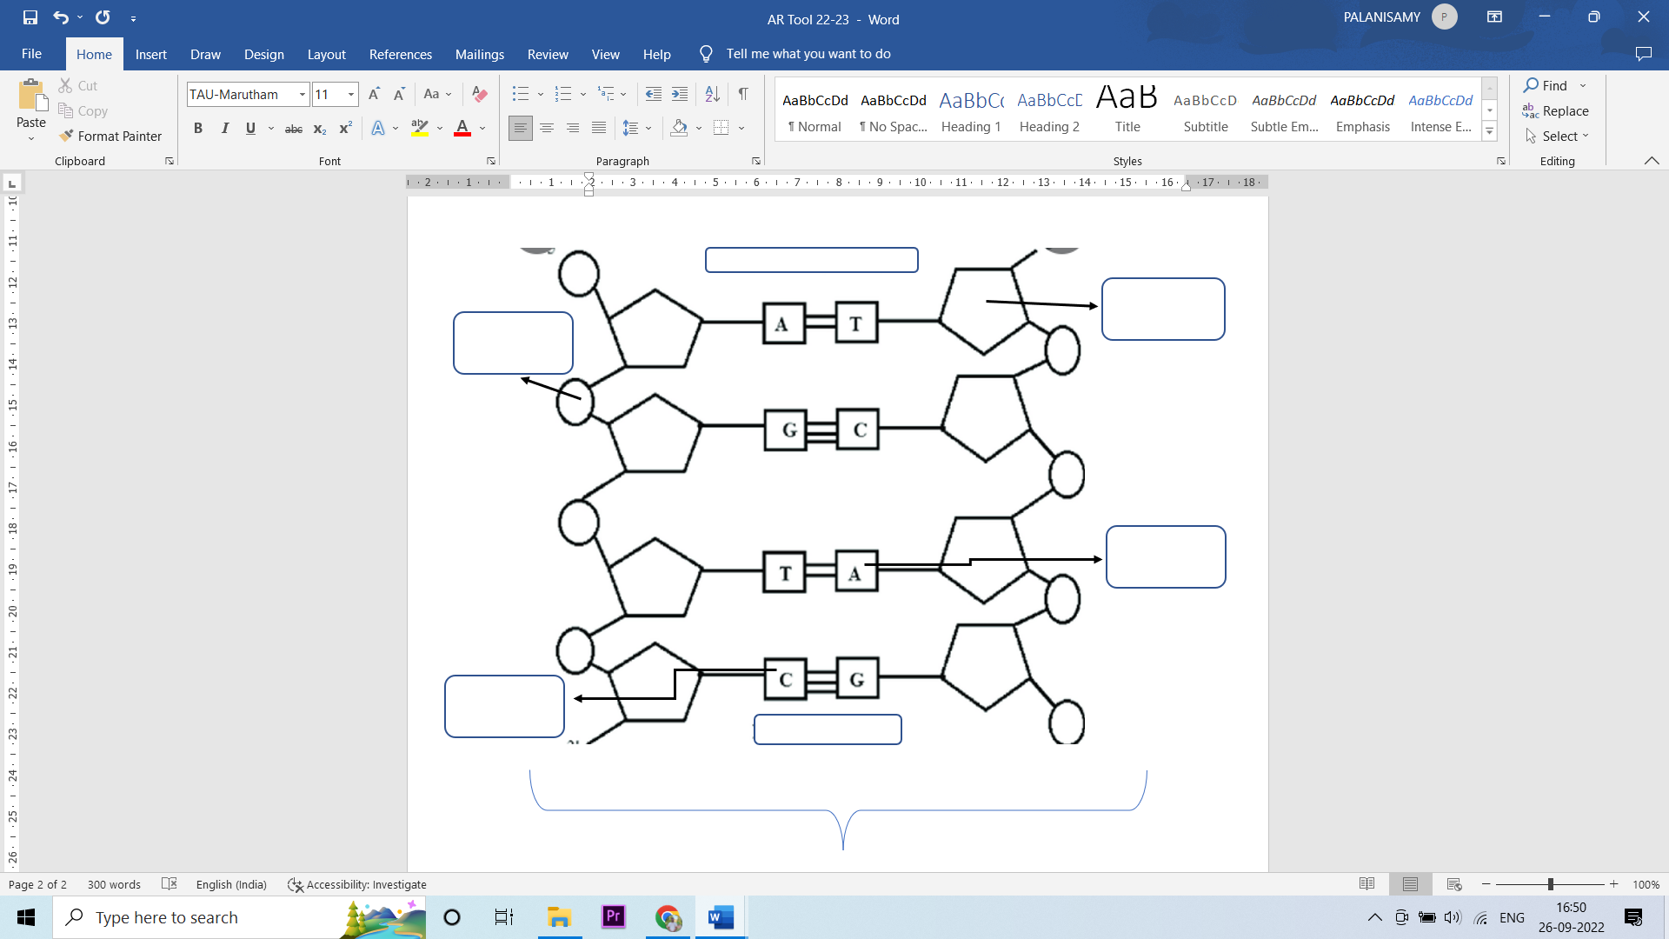

Annexture – 2 PHOTOS

