ENHANCING TEACHING OF IDENTIFIED CORE CONCEPTS IN SCIENCE AMONG UPPER PRIMARY TEACHERS IN KATPADI BLOCK

ACTION RESEARCH (2024 -2025)

Submitted by
Dr.G.Madhusudhana,
Senior Lecturer
DISTRICT INSTITUTE OF EDUCATION AND TRAINING
Ranipet

Submitted to
State Council of Educational Research and Training
Chennai – 600 006

DECLARATION

I hereby declare that the action research entitled ‘ENHANCING TEACHING OF IDENTIFIED CORE CONCEPTS IN SCIENCE AMONG UPPER PRIMARY TEACHERS IN KATPADI BLOCK”, is a record of first-hand research work done by me during the period of 2024 – 2025 and this work has not formed the basis for the award of any Degree, Diploma, Associateship, Fellowship or similar titles.

Signature of Action Researcher
Station: Ranipet
Date:

The Principal
District Institute of Education and Training
Ranipet
Vellore District
CERTIFICATE
This is to certify that the action research entitled ‘ENHANCING TEACHING OF IDENTIFIED CORE CONCEPTS IN SCIENCE AMONG UPPER PRIMARY TEACHERS IN KATPADI BLOCK” submitted by Dr.G.Madhusudhana is a record of original and independent work done by her within the period of three months during the academic year 2024 – 2025 has not formed the basis for the award of any Degree, Diploma, Associateship, Fellowship or similar titles.

Station: Ranipet
Date: Signature of the Principal

ACKNOWLEDGEMENT

It is an honour for me to express my sincere thanks to Mrs. Uma, Director, State council of Educational Research and Training, Tamil Nadu, for approving this action research proposal and her encouragement to conduct the research in a constructive manner.
I am extremely grateful to Dr.S.Balasubramanian, Principal, District Institute of Education and Training, Ranipet, Vellore, for his insightful guidance and valuable suggestions during the course of this research. I wish to express my sincere thanks to DEO (Elementary) Vellore district and BEO’s of Katpadi Block and Headmasters of Middle schools for permitting Science handling teachers to participate in this Action Research. I place my gratitude on record to Middle school Science handling teachers for actively taking part in the action research and supporting me to complete as scheduled and for their kind co-operation to carry out the action research successfully in the schools.
I record my heart-felt thanks to all the teaching and non-teaching staff members of District Institute of Education and Training, Ranipet, Vellore District for their kind co-operation for the successful compilation of this research project.
Dr.G.Madhusudhana

CONTENT

S.No | TITLE | PAGE NO
1 | Introduction | 1
2 | Background of the Action Research | 10
3 | Identification of the Problem | 10
4 | Need of the Action Research | 11
5 | Statement of the Action Research | 11
6 | Objectives of the Action Research | 11
7 | Probable causes of the problem | 12
8 | Action Hypothesis | 12
9 | Methodology | 12
10 | Analysis and Interpretation | 25
11 | Findings of the study | 34
12 | Net Gain of the Action Research | 36
13 | Educational Implications | 37
14 | Recommendations | 38
 | Bibliography | 40
 | Annexure I | 41
 | Annexure II | 48

ENHANCING TEACHING OF IDENTIFIED CORE CONCEPTS IN SCIENCE AMONG UPPER PRIMARY TEACHERS IN KATPADI BLOCK
Dr. G MADHUSUDHANA
SENIOR LECTURER, DIET, RANIPET
- INTRODUCTION
NCERT suggests in the Position paper https://ncert.nic.in/pdf/focus-group/science.pdf that at the upper primary stage the child should be engaged in learning principles of science through familiar experiences, working with hands to design simple technological units and modules (e.g. designing and making a working model of a windmill to lift weights) and continuing to learn more on environment and health through activities and surveys. Scientific concepts are to be arrived at mainly from activities and experiments. Science content at this stage is not to be regarded as a diluted version of secondary school science. Group activity, discussions with peers and teachers, surveys, organization of data and their display through exhibitions, etc. in schools and neighbourhood are to be an important component of pedagogy. Scientific concepts to be taught at this stage should be chosen so as to make sense of everyday experiences. Though most concepts should be arrived at from activities/experiments, a rigidly inductive approach is not necessary. Experience has shown that experiment-based science teaching is possible and viable under diverse conditions and with a very reasonable demand on resources.
The major guiding factors for the nature and scope of teaching science as an integrated course at the upper primary stage were that: • science is one; different disciplines of science are only tentative compartmentalization of the subject to facilitate the study of its different aspects; the integrated curriculum should highlight this unified nature of science, • curriculum should attempt to link teaching of scientific principles with daily life experiences of the learners, • science curriculum should stress more on the processes of science than the product, • teaching of science should lead to development of certain values, • curriculum should provide enough opportunities to learners to attain some basic levels of scientific literacy, and • curriculum should provide ample opportunities to the teachers to try and apply a variety of teaching strategies in the classroom to address wide variety of learners from various backgrounds.
Scientific concepts are often inconsistently defined in different fields or within a field (Doige & Day, 2012; Stromdahl, 2012). This problem is sometimes discussed in terms of the linguistic concept of polysemy, which means that one word is used with two or more related meanings (Stromdahl, 2012). For instance, studies have shown that students learning biology concurrently with physics and/or chemistry are commonly confused by the concept of energy (Gayford, 1986). Based on Lancor’s (2014) analysis, biology textbooks commonly adopt language indicating that energy is lost from systems (usually open systems). This is in contrast to physics textbooks, which emphasize the conservation of energy in closed systems. Thus, students can have difficulty coping with the multiple definitions of this scientific term.
Scientists focus on developing definitions that are accurate, whereas science educators are also concerned with whether students can understand these definitions. The intended purpose of a definition (how it will be used) can also subtly differ among scientists within the same discipline as well as among scientists from different disciplines. Specifically, Margenau (1942) suggested that there should be several different methods to define various scientific concepts, such as speed, electron, and mass. He explained that there were many different ways of defining a concept (e.g., mass) for different purposes. We hope that the proposed framework can provide students in countries where memorization has been encouraged ,a new method for approaching the study of scientific concepts that can improve not only understanding of science contents, but also science process and critical thinking skills. Students can then greatly benefit from an approach that views knowledge learning, including the learning of theoretical definitions of terms, should be constructed or co-constructed by the students with the facilitation of the teachers. In other words, the learning of a definition is more meaningful if students are guided to construct the definition or concept (Wong, Chu, & Yap, 2014), rather than memorizing
What are core concepts?
Core concepts are “big ideas” or foundational concepts that are central to a discipline (National Research Council 2007). They should provide coherence or structure to a field while being transferable across sub-disciplines within the field (Michael et al. 2017). AAAS's “Vision and Change” document (2011) states that core concepts “provide a set of overarching principles that are important throughout the living world, and their use in teaching biology lends meaning to the multitude of facts that the students encounter in any undergraduate biology course” (p. 11). Core competencies are the skills that students need to develop and apply within a field to “understand, generate, and communicate knowledge about the living world” (AAAS 2011, 11).
Core concepts are foundational ideas that experts agree are critical for all students in their discipline to learn, remember, understand, and apply (Libarkin, 2008). Over the past three decades, many disciplines have demonstrated the utility of reaching consensus on the core concepts of their discipline, and identifying ways to assess student attainment of those concepts. Research on core concepts has led to the adoption of new evidence-based approaches to undergraduate teaching and assessment in numerous disciplines, including biology, chemistry, genetics, physics, and physiology (e.g., Hestenes et al., 1992; Libarkin, 2008; McFarland et al., 2017). Examples of research-based core concepts include gravity in physics (Hestenes et al., 1992), homeostasis in physiology (Michael et al., 2017), and drug absorption in pharmacology (White et al., 2021). In all these disciplines, core concept research and development began with the identification of a consensus list of core concepts.
"Core concepts" generally refer to the fundamental, foundational ideas or principles that define a field, discipline, or subject matter, serving as building blocks for understanding and application.
A more detailed explanation:
Foundational Principles:
- Core concepts are the "big ideas" or foundational principles that are central to a scientific discipline. They are abstract principles that are essential for understanding a particular area of knowledge.
- Purpose:
They provide a framework for organizing information, making inferences, and solving problems within that domain.
- Core concepts are distinct from fundamental facts, which are basic information that is introduced to novices. Core concepts organize fundamental facts.
- Distinction from Competencies:
Core concepts are also distinct from core competencies, which refer to the fundamental skills necessary to be an effective practitioner in a field.
- Broader than Facts:
They are more encompassing than specific facts, content items, or topic areas, providing frameworks for understanding them.

- Unifying Themes:
They offer coherence to the discourse of a scientific discipline and facilitate teaching by identifying large unifying themes.
- Applicable Across Subdisciplines:
Core concepts should be applicable across all subdisciplines within a field.
- Timeless and Enduring:
They should reflect principles that are enduring, meaning they are less likely to change with new experimental findings.
Examples of Core Concepts in Science:
- Patterns, Order, and Organization: Recognizing patterns in the world and organizing phenomena at different scales.
- Form and Function: Understanding how the structure of something relates to its function.
- Stability and Change: Examining how systems maintain stability and how they change over time.
- Scale and Measurement: Considering the scale of phenomena and the importance of accurate measurement.
- Matter and Energy: Recognizing the fundamental roles of matter and energy in natural processes.
- Systems: Understanding how different parts of a system interact and function as a whole.
- Organization, Cause and Effect, Models, Systems, and Change: These are broad concepts that are ideas that can be found throughout the sciences.
- Science is Evidence Based: Science relies on evidence to support claims.
- Scientific Knowledge is Provisional: Scientific knowledge is subject to change as new evidence emerges.
- Scientists use theories and models to describe the natural and physical world: Scientists use theories and models to explain natural phenomena.
- Science is influenced by society: Science is influenced by and influences society.
Why are Core Concepts Important?
- Facilitate Deep Learning: They help students learn deeply by connecting disparate facts and ideas.
- Promote Understanding: They provide frameworks for understanding facts, content, and topic areas.
- Improve Teaching: They help educators identify large unifying themes that can be tailored to the level of the class and expertise of the instructor.
- Enable Students to Keep Pace with a Dynamic Field: As biological science rapidly generates new knowledge, core concepts help students understand the fundamental principles that remain constant.
Benefits of focusing on core concepts:
- Focusing on core concepts and competencies benefits both students and instructors. Core concepts reduce the amount of material to know, since the focus is no longer on memorization of content but on grasping larger ideas; this can foster retention of information and thus deeper comprehension (Chang et al. 2014). This is not to say that learning terminology and some content is not important; one has to learn the language and data available to communicate in the discipline. However, a focus on core concepts and competencies, and an appreciation of the limitations of existing information, means that anatomical systems and representative taxa are used as illustrations of the overarching themes and not as the end point of learning itself. This affords instructors the time and space to draw on their own expertise and affinities, which leads to more enthusiastic presence in the classroom
Core concepts provide scaffolding for further learning of new concepts since each concept should be transferable across disciplines (Wiggens and McTighe 2005). Each new system in which the core concepts are applicable should be easier to understand because the student already has a base of knowledge (Michael et al. 2017). Both core concepts and competencies contribute to the development of problem solving skills (AAAS 2011; Michael et al. 2017), a skillset projected to be more important for the future workforce than knowledge in any particular field (NSF 2018).
Learning outcomes are specific applications of the core concepts or competencies (Tansey et al 2013). Examples of learning outcomes for each core concept can be given. Identifying core concepts in science involves recognizing fundamental, overarching principles that provide frameworks for understanding scientific disciplines, going beyond specific facts or topics. These concepts are unifying themes that help organize knowledge and facilitate learning.
Researches on defining Criteria for a core concept:
Parekh et al. (2018) used three criteria—importance, difficulty, and timelessness—each rated on a 10-point scale. For example, a 10 for importance was described as “Absolutely essential; leaving this topic out would be egregious, and topic is appropriate for the target,” a 10 for difficulty was described as “Few, if any, students will have mastered this topic after the target course or curriculum” and a 10 for timelessness was described as “Foundational and highly relevant across essentially all technologies throughout the foreseeable future.” The article provides a framework for defining scientific concepts in primary, secondary, and university education by proposing teachers draw attention to five common features of a definition: object/system, nature/characteristics, cause/effect, mathematical expression/equation, and condition/ reference frame that can help students to consider four dimensions, including, ‘comprehensiveness,’ ‘precision,’ ‘consistency,’ and ‘circularity’ when learning science concepts. This framework can be used by science teachers to guide students to analyze and redefine scientific concepts in the classroom and may be especially beneficial for students in Asian countries where teachers and students often rely on rote memorization as a strategy for learning scientific concepts. https://www.researchgate.net/publication/347754903_A_Framework_for_Defining_Scientific_Concepts_in_Science_Education
It is interesting to note that while PISA results show that students in Asian countries are relatively better in science contents, they score less well on items assessing science process (Khine, 2015).Science is highly conceptual, so teaching science involves teaching various concepts. At the upper primary stage students are getting their first exposure to science as Physics, Chemistry and Biology, so it’s the best time to bring the right perspective of what it is “do science”. Scientific concepts to be taught at this stage should be chosen so as to make sense of everyday experiences. It is important to ensure that a majority of activities and experiments are inexpensive and use readily available materials, so that this core component of science curriculum can be implemented. Apart from simple experiments and hands on experiences, an important pedagogic practice at this stage is to engage the students in meaningful investigations. The greater the variety of pedagogical approaches employed the boarder will be the range of learners reached. Many students come out of schools as ‘scientific illiterates’. To minimize this, scientific concepts are to be arrived at, mainly from activities and experiments and from group activity, discussion, organization of data and henceforth.
Outcomes of understanding core concepts
Understanding core concepts significantly enhances teaching effectiveness by fostering deeper learning, enabling teachers to explain complex ideas clearly, and facilitating more effective teaching practices overall. By having a solid grasp of fundamental principles, teachers can build stronger knowledge foundations for students, making learning more meaningful and engaging.
- Differentiated Instruction:
- Tailored to Learning Styles:
Teachers can adjust their teaching methods based on how concepts are best understood by different students, creating a more inclusive learning environment.
- Addressing Misconceptions:
A strong understanding of core concepts allows teachers to identify and address common misconceptions or misunderstandings effectively.
- Clarity and Depth in Explanations:
- Breaking Down Complexity:
Teachers can simplify complex ideas by breaking them down into smaller, more manageable components, making learning accessible for students.
- Relatable Examples:
Using real-world examples and analogies to illustrate core concepts makes learning more engaging and memorable.

3. Fostering Critical Thinking and Problem-Solving:
- Encouraging Inquiry:
Teachers who understand core concepts can ask more probing questions that encourage students to think critically and solve problems independently.
- Connecting Ideas:
By understanding the relationships between different concepts, teachers can help students connect ideas across subjects and make broader connections to the real world.
- Enhanced Teaching Practices:
- Curriculum Design:
A deep understanding of core concepts allows teachers to create more relevant and engaging curricula that align with learning outcomes.
- Assessment:
Teachers can design assessments that evaluate students' understanding of core concepts rather than rote memorization, providing a more accurate measure of learning.
- Motivation and Engagement:
- Meaningful Learning:
When students grasp core concepts, they are more likely to see the value and purpose of their learning, leading to increased motivation and engagement.
- Lifelong Learning:
A strong understanding of core concepts can foster a love of learning that extends beyond the classroom.
Understanding core concepts is crucial for effective teaching because it allows educators to move beyond rote memorization and foster deeper learning. By grasping the fundamental principles of a subject, teachers can create more engaging and meaningful lessons that connect abstract ideas to real-world applications, leading to improved student comprehension and retention.

Here's how understanding core concepts benefits teaching
- Deeper Understanding:
Core concepts provide a framework for understanding a subject, allowing students to grasp the "why" behind the "what". This helps them see connections between different topics and build a more holistic understanding of the subject matter.
- Improved Retention:
When students understand the core concepts, they are more likely to remember and recall information. Deep learning, facilitated by understanding core concepts, leads to better long-term retention.
- Enhanced Problem-Solving:
A strong foundation in core concepts equips students with the tools to tackle complex problems and apply their knowledge in new situations.
- Critical Thinking Skills:
Exploring the relationships between different concepts encourages students to analyze, evaluate, and make connections, fostering critical thinking skills.
- Better Instruction:
Teachers who understand core concepts can design more effective lessons, providing targeted support and addressing misconceptions more effectively.
- BACKGROUND OF THE STUDY
Science is highly conceptual, so teaching science involves teaching various concepts. At the upper primary stage students are getting their first exposure to science as Physics, Chemistry and Biology, so it’s the best time to bring the right perspective of what it is “do science”. Scientific concepts to be taught at this stage should be chosen so as to make sense of everyday experiences. It is important to ensure that a majority of activities and experiments are inexpensive and use readily available materials, so that this core component of science curriculum can be implemented. Apart from simple experiments and hands on experiences, an important pedagogic practice at this stage is to engage the students in meaningful investigations. The greater the variety of pedagogical approaches employed the boarder will be the range of learners reached. Many students come out of schools as ‘scientific illiterates’. To minimize this scientific concepts are to be arrived at, mainly from activities and experiments and from group activity, discussion, organization of data and henceforth.
- IDENTIFICATION OF THE PROBLEM
In middle schools science is being taught by Graduate teachers not necessarily Science Graduates, even if Science Graduates are available in the school, it can be observed that Physical Science teachers teach Biological science and vice versa. Due to such uncertainties, the learning and comprehension of concepts introduced in upper primary science does not reach as intended. This is prevalent in all middle schools and learning is staggered. During school visits, training sessions, Model question paper preparation workshops the investigator observed that students’ rote learn definitions without comprehending the essence of concepts which is highly derogatory. This is predominantly observed in classes when the subject is not taught by the subject teacher. The comprehending of core concepts is not prevalent among non-subject teachers. It is also noticed that identification of core concepts of a lesson is not done by teachers themselves.
- NEED OF THE ACTION RESEARCH
In a effort to solve this, the investigator has planned to conduct sessions periodically to manoeuvre teachers to identify core concepts and systematically plan to teach them through various student- centered approaches based on the content devised by teachers themselves. After this action research teachers would learn to identify core concepts and develop indigenous strategies for classroom teaching learning processes.
The Action Researcher identified the following as identified points of concern.
- Teacher’s focus is on making students rote learn definition and answers to questions only
- Comprehending the definitions and even simple science terms is negligible
- Graduates of various streams teach science in middle schools and efforts taken to comprehend is not found
- Alternative methods to teach and make classroom interactive is insufficient
- Training on methodology as applicable to such classrooms are inadequate
- Teachers have been trained in various teaching learning strategies but are not exposed to identify core concepts and learning in depth of them
- Assessment of students are mostly knowledge based because of which focus is diverted to rote learning and not understanding
- Understanding of learning outcomes-based class room transactions is not found in most classrooms
- STATEMENT OF THE ACTION RESEARCH
Enhancing teaching of identified core concepts in science among upper primary teachers in katpadi block
- OBJECTIVES OF ACTION RESEARCH
- To support teachers in identifying core concept in science
- To guide teachers to develop various teaching learning methods for identified core concepts
- To study the effectiveness of teaching identified core concepts by using alternate strategies in classroom by assessing students

- PROBABLE CAUSES FOR THE PROBLEM
- Non-availability of subject teachers for each subject in science such as Physics, Chemistry and Biology
- Teachers have been trained in various teaching learning strategies but are not exposed to identify core concepts and learning in depth of them
- Assessment of students are mostly knowledge based because of which focus is diverted to rote learning and not understanding
- Understanding of learning outcomes-based class room transactions is not found in most classrooms
- ACTION HYPOTHESIS
After the intervention is completed, 90% of teachers will be teaching core concepts and not follow rote learning in classrooms. 80% of teachers will be habitually applying indigenous methods in classrooms by the end of the year
- METHODOLOGY.
  - Sample- 31 Graduate teachers teaching science in middle schools in Katpadi block
S.NO |  | NAME | ADDRESS OF SCHOOL | HANDLING CLASSES | MAIN SUBJECT
 | 1 | S.N.JAYAKUMAR | PONNAIPUDUR | 6,7&8 | MATHEMATICS
 | 2 | G.THAMARAI SELVI | JABRAPET, I | 6,7&8 | ZOOLOGY
 | 3 | J. JAYAKARAN | VIRUTHEMPET | 6,7&8 | ZOOLOGY
 | 4 | SHEELA RANI, | EARANTHANGAL | 6,7&8 | TAMIL
 | 5 | S.TAMILSELVI | PERUMALKUPPAM | 6,7&8 | CHEMISTRY
 | 6 | G PREMA | PEDDABODINATHAM | 6&7 | MATHS
 | 7 | ARIVUCHELVI. S | ASHOKNAGAR, | 6,7&8 | ZOOLOGY
 | 8 | SUDHAKARAN S, | BALAMUDHUR. | 6,7&8 | PHYSICS
 | 9 | KALAI SELVI . K | KALINJUR | 6,7&8 | MATHS
 | 10 | J MANJULA, | TK PURAM, | 6,7&8 | CHEMISTRY
 | 11 | N.MAHALAKSHMI | KAMMAVARPUDUR | 6&7 | MATHS
 | 12 | S VASANTHY | PALLIKUPPAM | 6,7&8 | CHEMISTRY
 | 13 | BALACHANDAR R | 66 PUTHUR | 6,7&8 | ZOOLOGY
 | 14 | SHEELA. | KATPADINORTH | 6&7 | ZOOLOGY
 | 15 | N LAKSHMI | SEVUR | 6&7 | ENGLISH
 | 16 | T. VENUGOPAL | ARUPPUMEDU | 6,7&8 | ZOOLOGY
 | 17 | KAVITHA | THENPALLI | 7 | MATHS
18 |  | D.SIVSRAMAN | MELKATTOOR | 6,7&8 | CHEMISTRY
19 |  | GOPALRAJ G | RAMANATHAPURAM | 6,7&8 | ZOOLOGY
20 |  | S.SATHYA DEVI | KALINJURMOTTUR | 6,7&8 | CHEMISTRY
21 |  | THENMOZHI.S | MUTHARASIKUPPAM | 6,7&8 | ZOOLOGY
22 |  | GOPALRAJ | RAMANATHAPURAM | 6,78 | ZOOLOGY
23 |  | G PREMA. | PEDDABODINATHAM | 6,7&8 | BOTANAY
24 |  | A. K. SUMATHI | KUPPATHAMOTTUR | 6,7&8 | ZOOLOGY
25 |  | G. VIJAYA | PONNAIPUDUR | 6,7&8 | ENGLISH
26 |  | R.KAVITHA. | THENPALLI | 6,7&8 | MATHS
27 |  | S.SATHYA DEVI | KALAINJAR MOTTUR | 6,7&8 | CHEMISTRY
28 |  | S .MALARVIZHI | KATPADI SOUTH | 6,7&8 | ZOOLOGY
29 |  | R.KAVITHA | THENPALLI | 6,7&8 | MATHS
30 |  | K.KALAISELVI. | KALINJUR | 6,7&8 | MATHEMATICS
31 |  | N.UDAYAKUMAR | KOKKERI | 6,7&8 | TAMIL
Distribution of Teachers based on their subjects studied in Under Graduate course

  - Design- Single group experimental
The entire group of teachers were considered to be single group. The study is of experimental in which interventions were applied to all teachers.
  - Research Tools
- Pre test was designed as an entry Tool with the objective of serving as an introspection and coerce teachers to think about possibilities that have not been explored and vast areas that have been ignored/skipped.
- Assessment tools for each lesson that would be taught in the third term in class 6, 7 and 8
- Journal: An elaborate journal entry by each teacher based on instructions given by Researcher
- Exit tool: A combination of various assessment questions from Assessment tools of class 6,7,&8 that focused on concept and pedagogy.
- Content based Tool for students: A content-based question paper that contains 10 questions for classes 6,7,&8.
  - Description of the Research Process
Data collection
Pre-test was conducted through google forms in a workshop after which orientation for 31 teachers was given.
Assessment tool for classes 6,7& 8 for Lessons of third term was conducted through google forms
Post test
- A combination of various assessment questions from Assessment tools of class 6,7,&8 that focused on concept and pedagogy through google forms.
- Content based Tool for students: A content-based question paper that contains 10 questions for classes 6,7,&8.
Intervention
- Planning the intervention
Prior to conducting workshop, all science handling teachers in middle schools were identified and officially informed to attend the workshop
Based on the identified probable caused and the determined goal, step by step interventional strategies were planned. Of the identified probable causes few were administrative which is beyond the scope of this Research .
So the other areas such as…
- Teachers have been trained in various teaching learning strategies but are not exposed to identify core concepts and learning in depth of them
- Assessment of students are mostly knowledge based because of which focus is diverted to rote learning and not understanding
- Understanding of learning outcomes-based class room transactions is not found in most classrooms
were identified as the areas of focus.
Each component of probable solutions was dealt with individually and Action plan was developed as follows

PROBABLE SOLUTION | PROCEDURAL METHODOLOGY APPLIED
Training teachers to identify core concepts based on analysis of lesson | Conduction of Workshop  -Deliberation on identification of core concepts  -Assessment tool of Lesson AIR encompassing core concept, methodology, QR codes and assessment followed by Intensive deliberation
Orienting teachers to delve into core concepts by deep learning | Assessment Tools for each lesson consisting of Challenging Questions, Critical thinking questions, Reflective thinking which can be answered only by In-depth understanding, Meaningful learning and Profound comprehension
Devising teaching methods for core concepts | Discussion of prevalent methods followed by introduction of other interactive and student centred methods
Brainstorming to devise alternate classroom transaction methods other than existing in textbook and already done in classrooms | Brainstorming session in workshop sessions and in google meet
Applying such indigenous methods in classrooms | Structured Action plan with focus points and time line tasks
Conduction Of Pre-Test
The link to the pre- test- Entry Tool was shared to the group. Instructions were given to complete the google form and submit. No time limit was given. There was no restriction regarding referring to textbooks, discussion, searching in internet, etc. Questions 1 to 3 collected personal details like Name, Address of school, Years of experience, subjects studied in graduation, Questions from 4 to 17 was content based and Questions 18 to 20 was Pedagogy based.
Interventional strategies
Since this intervention is being conducted to Teachers who are adults, Adult learning principles were Integrated as a core principle in this framework
Adult learning principles, often referred to as andragogy, are a set of guidelines focusing on how adults learn best. These principles emphasize self-direction, experience-based learning, practical application, and the importance of relevance and purpose in the learning process.
- Adults have a higher sense of self-direction and motivation
- Adult learners are much more self-directed and motivated than young learners.
- Adults tend to learn because they want to or they see the direct benefit of learning, rather than because they are told to or are expected to. However, just because adults have a larger reservoir of motivation, it doesn’t mean that they will learn just anything.
- Adults have to see the benefit, value and purpose of learning. Learning programs should clearly demonstrate what the learner gains from their interaction, or learners will be quick to disengage.
The principles of Self-directed Learning theory, also known as SDL, was developed in 1997 by D.R. Garrison and builds on Malcolm Knowles’ theory of andragogy.It folds in concepts of how adults self-manage, creating a theory with the premise that the adult learner:
- Takes the initiative to understand what they need to learn. The learner sets learning goals, finds the resources they need, creates, and follows a learning plan, then they evaluate their own results.
- Will seek out those who can help them, including teachers, mentors, or peers.
- Will respond positively to being in control of their own learning journey, putting in the time to make informed decisions, and incorporate learning on a daily basis.
Self-directed learning is well suited for self-motivated learners, as well as those who respond well to technology-based learning.
Self-directed learning would be helpful in this, as they could seek out apps, books, or conversation groups to help them learn. They can review their own progress, and there will be clear answers as to whether or not they are using the language correctly. Learners need to be able to evaluate their own results to see how they are progressing with their learning and assess what areas they need to focus on and allow them to drive their own learning journey. They can be encouraged to identify their own learning needs, plot how to achieve their goals, find resources, then assess their own progress.
Online learning is an ideal environment for this type of learning, and gives them the ability to follow flexible learning paths, access to services that curate and recommend learning content to prevent skill gaps, and AI that is developed to deliver content tailored for each individual’s needs.
Harnessing this principle to promote learning was done by:
- Online platforms were new to few teachers. Collaborative learning helped to overcome this challenge, Techniques to search for deeper comprehension, resources for better learning were provided
- Flexible learning paths was given by giving stipulated time as requested by teachers
- Tech savvy teachers and science teachers finished earlier than others. This was not used to force rest of them to complete earlier.
- Learning content to cover skill gaps were shared in the whatapp group by addressing cues and doubts raised by teachers
- Adults use their life experience to facilitate learning
Adult learners rely heavily on their experiences when they engage in learning, and they benefit from training programs that understand this. Content that draws from real-world examples, relatable scenarios and builds on direct experience will lead to a more meaningful understanding of the subject.. Although using existing experience can help adults more quickly understand new information, there is a downside. The experience that learners draw from might be outdated, incorrect, biased, or incomplete.
Learners should be aware of these common challenges and know how to guide themselves to new conclusions. Understanding how to search for resources, expert opinions, proven data and relevant publications is a key skill that an adult learner will need to use.
The learning principle Social Learning Theory presumes that learners:
- Will gain information by combining their own experiences with observations of the rewards and punishments that others receive for their actions.
- Observe the response to behavior within the workplace and gain understanding as to how they should act from that.
- Imitate the behavior of those around them who they respect.
Harnessing this principle to promote learning was done by:
- Providing bias training, to help learners understand how to acquire new information that might be at odds with their previous experience. This was done by emphasising on examples that were already know to core subject teachers but unknown to others.
- Developing templates that draw heavily on scenarios that teachers in their day-to-day roles.
- Adults are focused on achieving goals
Adults enter the learning process focused on results. They need to know how the information will help them achieve their goals, whether personal or professional.
Harnessing this principle to promote learning was done by:
- In designing this learning intervention, it was ensured that the learner was given plenty of tools and information that will help them reach their goal. Adult learners were energized and motivated when they see how the content they are engaging with made them more resourceful.
- Learning paths, which are made up of various stages, each with a goal that the learner must meet and an evaluation that must occur before the learner can progress to the next stage.
- Adults need to know how the information is relevant
To properly engage a learner, the relevancy of the information within the training program must be highlighted.
So, both the immediate, short-term relevancy and the long-term benefits of engaging with the content should be highlighted in such a way that the learner will immediately dedicate themselves to learning.

Harnessing this principle to promote learning was done by:
This study was being developed to upskill teaching competency, the short-term relevancy might be that they will read their lessons allotted to understand core concepts. The long-term benefit is that they will become a more efficient teacher who irrelevant of their graduated subject will become competent enough to teach all science lessons and make it habit to Prepare before teaching, visualise their class, take up small inevitable challenges in class as a whole be a teacher that they wanted to be.
The short-term relevancy will demonstrate what they will learn in the course that is pertinent to their role. The long-term benefit is how that knowledge will make them better at their role.
A learning environment was developed to provide learners with the relevant information needed for their learning path, taking advantage of tools such as courses, videos, or apps.
- Adults are practical
When developing a training program, keep in mind that the knowledge gained should be applied immediately.
Adults learn quickly and remember what they learn when they can turn around and apply that knowledge in their role.
Learning materials should be constructed with practical examples, using real-world scenarios and problem-solving that requires learners to access their experience and knowledge.
Allow learners to set their pace, and allow them to forge their own path. Online learning is well suited for this type of learning, as learners can access learning content on their own schedule.
This type of knowledge acquisition will ensure that the learner remembers the content much more fully than with more static methods.
Harnessing this principle to promote learning was done by:
- Focussing on delivering knowledge that can be quickly be applied in day-to-day role.
- A month was set aside after knowledge acquisition for learners to practice their new skills with a action plan
- Adults are looking for help and mentorship
Adult learners understand that looking to an experienced role model will help them in their learning journey.
Creating opportunities for mentorship can add a great amount of value for both the mentor and mentee and has the added bonus of developing relationships within and across teams.Learning by example is a powerful way of accessing new knowledge, allowing learners to quickly gain information and simultaneously avoiding common mistakes.
Harnessing this principle to promote learning was done by:
The concept Social Learning Theory states that learners will gain information by combining their own experiences with observations of the rewards and punishments that others receive for their actions, and that they will imitate the behavior of those they respect.
Harnessing this principle to promote learning was done by:
Online Google forums and workshops allowed colleagues in different schools to share their wisdom and connect with each other. and a culture of learning and knowledge sharing throughout the meet and workshop was created.
Conduction of Workshop
Training teachers to identify core concepts based on analysis of lesson A workshop was held for all teachers which was conducted as follows
The objective of workshop was elaborated and a whatapp group was formed
Session 1: Conduction Of Pre-Test
The link to the pre- test- Entry Tool was shared to the group. Instructions were given to complete the google form and submit. No time limit was given. There was no restriction regarding referring to textbooks, discussion, searching in internet, etc…
- Observations during the Tool administration:
- Few teachers had difficulty in using google form
- Though no restriction was imposed, only few teachers referred to their text book
- None of them searched through internet
- No discussion between teachers took place.
- Almost all finished it very quickly
- Discussion after all submitted the google form
Focus points
- Question from 4 to 17 was content based
- Questions 18 to 20 was Pedagogy based.
- Each question was deliberated by researcher and answers were sought from teacher tailed by interactive discussion
- Based on this, following are the observations
- Teachers have not read the content fully
- Many teachers guessed the answers based on their knowledge/experience which was wrong
- None of the teachers had any doubt about their own answers though their answers were found wrong later
- Differences between respiration and photosynthesis is not known even to botany teacher
- Gas jar experiment was never conducted even in the simplest method
- Real life applications were very scarce
- QR codes ,”more to know” facts and manarkeni videos are not used by teachers
- Many teachers have already concluded on many scientific concepts which are not precise because they have not delved into the concept and failed to comprehend it
Session 2 : Orienting teachers to delve into core concepts by deep learning
Key points:
- As answers to each question was deliberated, Teachers were made to realize that concept identification followed by comprehending each concept was important.
- With each example, teachers slowly learnt the art of using scientific evidence, data for comprehension and how guesses lead to wrong interpretation. (Example: Photosynthesis and Respiration, combustion and burning)
- Methods that can be used in classroom other than demonstration and Drawing using blackboard such as Action research, project, story- telling, documented problem solving, interactive discussion, small group discussion between students, inductive and deductive teaching, Inspiring stories leading to inventions were elaborated through discussion, powerpoint presentation and videos.
- Teachers then opened QR codes given in textbooks, discussed about “more to know” boxes in small groups and presented their findings in large group
Brainstorming
Alternate classroom transaction methods other than existing in textbook and already done in classrooms were brainstormed and discussed elaborately.
- Objective of Assessment tools was explained as follows:
1. Ensure reading (not skimming or scanning)the entire lesson
2. Familiarising the content of lessons
3. Identifying core concepts
4. Comprehending all content
5. Realizing that various methodology of teaching is necessary
6. Relating content with real life situations
7. Devise necessary various simple experiments/ activities.
Session 3: Action Plan
Researcher then presented the flow of action for the following one month as follows:
Task 1;
One week of intense and deep reading and comprehending Lesson, Magnetism (Class7) which will be followed by assessment of the lesson through google form.
Task 2;
One week of intense and deep reading and comprehending Lesson, Light (Class7) which will be followed by assessment of the lesson through google form.
Task 3;
One week of intense and deep reading and comprehending Lesson, Crop Production and Management (Class7) which will be followed by assessment of the lesson through google form.
All the teachers grasped the nuances of comprehending and identifying core concepts after completing the google forms and submitting it.
Task 4: Classroom teaching and self-assessment
Teachers were then instructed to follow the stipulated guidelines for four weeks in science class
On the previous day of your science class...
1. Mentally decide concepts to be taught each period and methodology for each content
2. Search and finalise examples, experiments, activity, real life situations for each concept
3. Prepare assessment questions (other than book back questions)
During classroom teaching
1. Note the difference in classroom transaction
2. Observe behaviour of students
3. Challenges faced if any...
Journal
At the end of the day, write down science class experience in detail which should contain, methodology adopted for teaching, interaction between teacher and students, Experiments / Activities/Examples used during teaching, Questions raised by teacher, Questions that were/were not answered by teacher, any difference in listening and comprehending by students
This document should be submitted on the final day of the AR workshop...end of January 2025

Schedule of Monitoring and Periodic assessment
- Submission of Google forms
Monitoring of submitting of google forms were done by ensuring teachers submit their screenshots of completed google forms. A duration of Five working days were given for completion of google forms. Teachers were encouraged to search for more information and comprehending by suggesting web sources and Videos for further references.
- Unpacking the solutions
After each google form was submitted by all teachers, an online meeting was commenced to deliberate on each answer and why other answers in MCQ type were wrong. Many teachers realized that their answers were mostly wrong because of non -comprehending and not searching enough to comprehend it. This phenomenon was increasingly observed from Task 1 to Task 3. While answering Lesson “crop management” in Class 8, teachers showed a considerable increase in answering questions correctly.
- Periodical school visit by Investigator
The Investigator visited schools during their science class and observed the transactions in the classroom. It was observed that questions that were asked in the Google form were given priority and discussed in the classroom. It was wonderful to observe that concepts so far not taught or even read through were explained in the classroom.
- Real Stories, Real Impact:
Videos and testimonials of children showcased the transformative Learning experiences which demonstrated the positive change in Teaching learning process from Chalk and Talk, reading from textbook to demonstration by teacher, experiments conducted by students in pair or individually, field visits, and activities.
- Teachers shared their experiences in the whatapp group too.
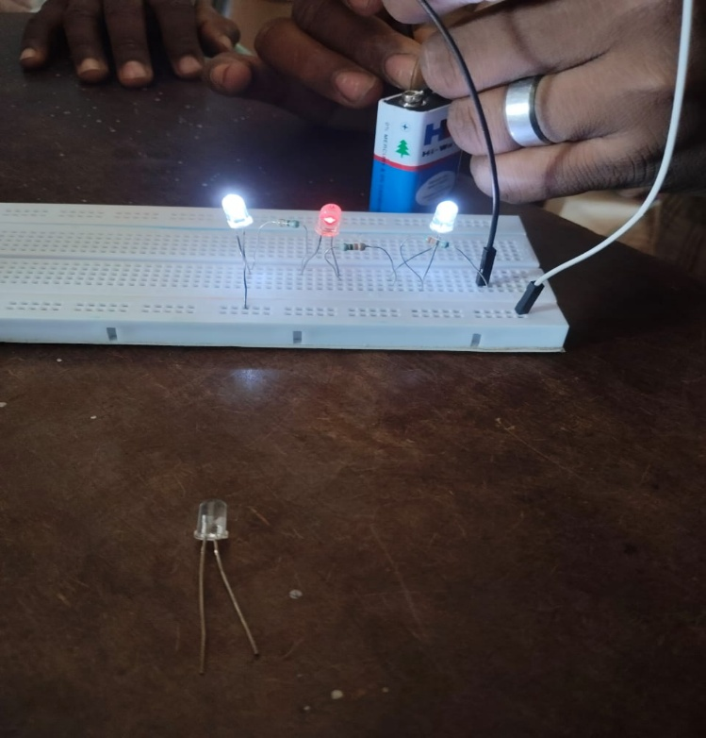 | 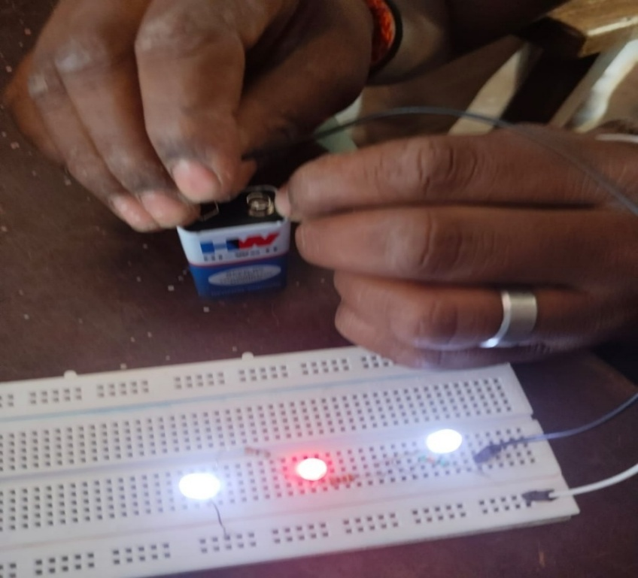

- Impact of One-month long Action Plan
The impact was assessed through an EXIT tool. Impact of Action Research on students was studied by comparing scores of Test containing 10 items based on content on Class 6,7 &8.
Academic support sessions
- The entire framework of this Action Research from the initial session was repeatedly stressed on Open learning, Discussion based strategies, Evidence based learning and A NEUTRAL LEARNING ENVIRONMENT
- Based on such a assured environment Teachers had access to Researcher ,Sources, Co faculty.
- Phone calls, Messages and doubts were encouraged which lead to teachers discussing with Researcher without anxiety
- Bimonthly google meets were held to clarify doubts and also to self -assess their own journey and modify if necessary
- Model lesson plan which was earlier circulated was iterated for ensuring understanding.
CONDUCTION OF POST TEST
Post test for all 31 science handling middle school teachers was conducted through a google form as a exit tool which consisted of items based on comprehension of core concepts, classroom transaction processes, from classes 6,7&8 viz., AIR,LIGHT, MAGNETISM AND CROP MANAGEMENT.
Impact of intervention was studied by comparing scores obtained by students studying in a school where teacher was not involved in this Action research and the students of school where the teacher was involved in this study.
DATA ANALYSIS
The responses obtained from pre -test and post- test have been analysed and discussed. The achievement test scores obtained from the control and experimental group of students is the indicator for the impact of the intervention.

10.ANALYSIS AND INTERPRETATION
10.1 ANALYSIS OF PRE-TEST RESULTS
Figure 10.1
From figure 10.1, it is evident that 58% teachers have more than 10 years of experience.

Figure 10.2
From figure 10.2, it is derived that 29% of the sample are Male teachers while 71% are female teachers.

10.2 ANALYSIS OF PRE-TEST- TEACHERS’ PERSPECTIVE- RESULTS
Figure 10.3-Pedagogical techniques prevalent in classroom
Inferences
From Figure 10.3, it is evident that 36% teachers use Demonstration method and 19% of teachers use Drawing on blackboard with explanation 3% use both which are teacher centric method in classroom. A Meagre 3% of teachers only use Project, hands on learning as standalone methods. 6.5% of teachers use documented problem solving (which may not be structured and in a framework). 10% of teachers use a combination of Drawing on blackboard with explanation, Demonstration and hands on learning which is appreciable. As a summative ,60% teachers use teacher centric teaching,3% use student centric and the rest use the combination of both.
Figure 10.4. A Teacher’s perspective on skills obtained by students
Inferences
Nearly 42% of teachers believe that experimenting skills are only obtained in a science class.10% of teachers believe that observation skills are obtained.24% of teachers only believe that all the science process skills can be obtained in a interactive science classroom.
Figure10.5. Teacher’s Opinion on, “students understand all science concepts”
Inferences
On a scale of 1-10, from the bar graph, most of the teachers scale between 5-8 which interprets that they believe that their students understand all science concepts

Figure 10.6. Measurement of “open to learning” among teachers
Inferences
This question indirectly takes effort to measure teachers’ attitude towards taking “extra effort, that one Mile” towards classroom teaching process. 45% of teachers acknowledge that additional effort is required and the rest think that additional efforts are not required which could be rephrased as “my status quo is good”. This also closes the window open to learning. This implies that they may not willing to change their approach in classroom.

10.2 ANALYSIS ON RESPONSES TO CONTENT BASED ASSESSMENT
The action research was conducted in the term of the academic year. Hence lessons taught in classes 6,7& 8 in third term viz., AIR, LIGHT, MAGNETISM AND CROP PRODUCTION AND MANAGEMENT were included in the assessment tool for Entry tool and in Exit tool.
Questions based on content in the lessons are:
Air-4
Light -10
Magnetism -10
Crop Production and Management-15
The total scores secured in the entry tool and exit tool are converted into percentages and tabulated.
Table 10.1
S.No | Name of teacher | AIR(%) |  | LIGHT(%) |  | MAGNETISM(%) |  | CROP PRODUCTION AND MANAGEMENT(%)
S.No | Name of teacher | Entry test score | Exit test score | Entry test score | Exit test score | Entry test score | Exit test score | Entry test score | Exit test score
1 | S.N.JAYAKUMAR | 45 | 67 | 46 | 72 | 35 | 67 | 45 | 67
2 | G.THAMARAI SELVI | 48 | 78 | 59 | 82 | 68 | 78 | 54 | 78
3 | J. JAYAKARAN | 55 | 89 | 56 | 89 | 48 | 89 | 56 | 89
4 | SHEELA RANI, | 35 | 58 | 37 | 62 | 67 | 58 | 35 | 78
5 | S.TAMILSELVI | 58 | 79 | 58 | 85 | 54 | 79 | 59 | 79
6 | G PREMA | 60 | 89 | 62 | 89 | 78 | 89 | 61 | 89
7 | ARIVUCHELVI. S | 45 | 90 | 47 | 92 | 46 | 90 | 46 | 90
8 | SUDHAKARAN S, | 35 | 80 | 39 | 83 | 68 | 80 | 42 | 80
9 | KALAI SELVI . K | 68 | 78 | 72 | 79 | 58 | 78 | 68 | 78
10 | J MANJULA, | 48 | 78 | 52 | 80 | 34 | 92 | 48 | 78
11 | N.MAHALAKSHMI | 67 | 80 | 68 | 81 | 56 | 83 | 68 | 80
12 | S VASANTHY | 54 | 89 | 58 | 92 | 68 | 79 | 66 | 89
13 | BALACHANDAR R | 78 | 98 | 80 | 98 | 79 | 80 | 78 | 98
14 | SHEELA. | 68 | 78 | 67 | 82 | 56 | 81 | 46 | 78
15 | N LAKSHMI | 58 | 80 | 56 | 85 | 52 | 92 | 58 | 80
16 | T. VENUGOPAL | 34 | 67 | 34 | 67 | 82 | 67 | 62 | 88
17 | KAVITHA | 56 | 78 | 56 | 79 | 63 | 78 | 41 | 78
18 | D.SIVSRAMAN | 68 | 90 | 67 | 93 | 62 | 90 | 44 | 90
19 | GOPALRAJ G | 79 | 95 | 82 | 95 | 41 | 96 | 64 | 95
20 | S.SATHYA DEVI | 67 | 93 | 63 | 95 | 44 | 93 | 47 | 93
21 | THENMOZHI.S | 65 | 83 | 62 | 85 | 36 | 83 | 65 | 83
22 | G PREMA. | 45 | 85 | 41 | 86 | 47 | 86 | 45 | 85
23 | A. K. SUMATHI | 44 | 79 | 44 | 79 | 71 | 79 | 44 | 79
24 | G. VIJAYA | 35 | 68 | 36 | 69 | 67 | 69 | 35 | 76
25 | R.KAVITHA. | 45 | 67 | 47 | 67 | 65 | 67 | 45 | 68
26 | S.SATHYA DEVI | 65 | 87 | 65 | 88 | 71 | 88 | 65 | 78
27 | S .MALARVIZHI | 69 | 86 | 71 | 86 | 67 | 89 | 69 | 88
28 | R.KAVITHA | 67 | 95 | 67 | 95 | 53 | 96 | 67 | 97
29 | K.BHUVANA | 54 | 76 | 53 | 79 | 54 | 77 | 54 | 78
30 | N.UDAYAKUMAR | 35 | 58 | 36 | 57 | 35 | 75 | 35 | 89
 | MEAN SCORE | 51 | 85.6 | 56 | 82 | 58 | 85 | 53 | 89
 | GAIN SCORE |  | 34.6 |  | 26 |  | 27 |  | 31
Fig 10.6 Pictorial representation of Mean Scores  of Pre-Test | Fig 10.7 Pictorial representation of Mean Scores of  Post-Test

Fig 10.8 Pictorial representation of Comparison of Mean Scores of Pre- test and Post-Test

The mean scores of all teachers in the Pre- test in the Lesson AIR is 51%, Lesson LIGHT is 56%, Lesson MAGNETISM is 58%, Lesson CROP MANAGEMENT AND PRODUCTION is 53%. The mean scores of all teachers in the Post test in the Lesson AIR is 86%, Lesson LIGHT is 82%, Lesson MAGNETISM is 85%, Lesson CROP MANAGEMENT AND PRODUCTION is 89%.
And the Mean Gain score Lesson AIR is 35, Lesson LIGHT is 26, Lesson MAGNETISM is 27, Lesson CROP MANAGEMENT AND PRODUCTION is 36.
10.3 IMPACT STUDY ANALYSIS
To study the impact of the methodology ,a sample achievement test was conducted to a set of students. A section who participated in this Action research was taken as Experimental group and students of the equivalent age, class of another school not participated in the study was taken as a Control group. Same question paper was administered to both set of students and their results were compared.

Table 10.2
 | CONTROL GROUP
 | NAMES | MAX 30 | PERCENTAGE
1 | ARCHANA J | 18 | 60
2 | DHARSHA S | 22 | 70
3 | JEEVITHA P | 13 | 43
4 | DIVYA S | 20 | 66
5 | KALAIYARASI R | 25 | 83
6 | PREETHA T | 17 | 56
7 | RITHIKA SARAN K | 25 | 83
8 | SADHANA DEVI K | 22 | 73
9 | SHAMYA MALA M | 13 | 43
10 | TAMILARASI V | 23 | 76
11 | YUVASRI K | 22 | 73
12 | AKASH S | 8 | 26
13 | ARUN KUMAR P | 23 | 76
14 | DINESH KUMAR J | 13 | 43
15 | SIVAJI S | 18 | 60
16 | NITHISH KUMAR P | 15 | 50
17 | KATHIRVEL V | 14 | 46
18 | UMESH P | 20 | 66
19 | GOWTHAM T | 11 | 36
20 | MADHAN S | 12 | 40

 | EXPERIMENTAL GROUP
 | NAMES | MAX 30 | PERCENTAGE
1 | ABINAYA S | 30 | 100
2 | BOOMIKA S | 29 | 96
3 | LITHIKA P | 17 | 56
4 | LOGAPRIYA P | 23 | 76
5 | NAVEENA V | 25 | 83
6 | SUBHA R | 21 | 70
7 | VIJAYA LAKSHMI S | 22 | 73
8 | YUVASHREE T | 28 | 93
9 | BALAJI V | 22 | 73
10 | GOVIND S | 15 | 50
11 | GURUMOORTHY T | 16 | 53
12 | HARISH P | 19 | 63
13 | JAYA PRASANTH R | 20 | 66
14 | JITHISH K | 19 | 63
15 | KAMALESH G | 20 | 66
16 | KOSHIGAN S | 25 | 83
17 | LOKESHWARAN R | 22 | 93
18 | MANOJ P | 24 | 80
19 | PUNITH S | 18 | 60
20 | SANJAY M | 27 | 90

Average score of Control group of students was found to be 51 and that of experimental group found to be 81.
  - FINDINGS OF THE STUDY
Core concepts are the "big ideas" or foundational principles that are central to a scientific discipline. They are abstract principles that are essential for understanding a particular area of knowledge. They provide a framework for organizing information, making inferences, and solving problems within that domain. Core concepts are distinct from fundamental facts, which are basic information that is introduced to novices. Core concepts organize fundamental facts. Core concepts are also distinct from core competencies, which refer to the fundamental skills necessary to be an effective practitioner in a field. They are more encompassing than specific facts, content items, or topic areas, providing frameworks for understanding them. They offer coherence to the discourse of a scientific discipline and facilitate teaching by identifying large unifying themes.
Focussing on these points Researcher framed a intervention before which a Entry tool was administered and after the intervention Exit tool was administered. During the process for the purpose of self-assessment and to provide focus points, google assessment forms for each lesson in third term for classes 6,7,& 8 were framed and answers discussed in Open forum to allow teachers to self-analyse areas that needed more comprehension and learning which developed proficiency in the subject. This was the pivotal point of the intervention because teachers who have not completed graduation in science were teaching it and completed graduation in their core subject had to teach other branches of science. This indirectly coerced teacher to read in depth, search for answers for clarity, develop activities /experiments/methods for interactive classroom transactions.
- Penning Insights: A Review of Journal entries
- Reflections of Teachers on Personal Growth
Teachers expressed that journal helped them in
- Planning for the class room teaching process
- View it through student learning “lens”
- Visualising the flow of content
- Predicting the questions that may arise and prepared for their answers
- Reviewed all the QR codes and searched Manarkeni Apps for suitable videos
- Insights Discernible
From Researcher’s Desk
- Teacher’s journal showed their paradigm change in planning their class based on core concepts identified, choosing methodology and entire transactions
- Few had chosen ALM method and added innumerable points of value in Reinforcement section, specific addendums of videos, photos, QR codes and Manarkeni videos
- A marked shift in questions asked revealed the Transformation from WHAT to WHY, EXPLAIN etc.
- An entire lesson was very carefully divided into required number of classes , portions clearly demarked, diverse array of methods was planned each with its unique approach
- The journal entry also revealed the participatory approach followed in the class, tightly packed schedule
- Metamorphosis from the first lesson to the last lesson was very distinct.
Journal entries of teachers revealed their paradigm shift in classroom processes.
- Specific student centered activities have been framed and executed
- In reinforcement activity of ALM methodology videos, additional information leading to comprehension were discussed
- All QR codes have been put into action and conducted
- Questions discussed in Assessment tools were discussed in classes
- Manarkeni vidoes which were not used earlier were screened .
- Teachers who did not conduct experiment such as simple Gas Jar experiment no, have improvised and used it
- Local materials were procured with the help of students, family and co teachers
- Learning outcomes have been easily identidfied and correlated with the content of the lesson
- Experiments in light and Magnetism lesson were conducted.
- For the lesson the methodology has changed from Classroom to field visit
- From Mean gain scores of Entry and Exit Tools
- Teachers who had not completed their graduation in science have scored low in Entry tool but scored remarkably high in exit tool
- Few teachers who have graduated in science have scored good marks even in their Entry test but have gained in Exit tool.
- When averages score from Assessment tool -AIR to Assessment tool- Crop management and Production are compared there is a gradient in scores obtained in Entry tools itself which implies efforts taken by teachers in comprehending has gradually increased.
- Lesson LIGHT was difficult to comprehend by teachers which was implied from the comparatively less increase in Mean gain score.
- Role of asking questions that spark thinking are very important in making teachers to comprehend and search. It indirectly throws a challenge to them and the drive to search travels in the desired direction. Inquiring minds lead to learning and searching.
- Scaffolding teachers in areas that they are reluctant to tread is the key to make teachers comprehend
- Self- directing theory and Social Learning theory are crucial to obtain desired changes among adult learners like teachers
- On analysing answers given by teachers in all assessment tools, it was derived that there was a gradual increase in answering questions that probed their thinking.
- Teachers are capable of crossing their own limitation to perform better when right tools are administered.
- Middle school graduate teachers should be given more attention particularly when they are teaching subjects which they are not expert at.
  - NET GAIN OF THE ACTION RESEARCH
The instructional interventions across the four science lessons—AIR, LIGHT, MAGNETISM, and CROP MANAGEMENT AND PRODUCTION—have led to positive learning outcomes as reflected in the mean gain scores. The highest mean gain was observed in CROP MANAGEMENT AND PRODUCTION (36), indicating strong comprehension and effective teaching strategies in this area. AIR followed closely with a mean gain of 35, also reflecting significant conceptual understanding. Comparatively, the lessons on MAGNETISM (27) and LIGHT (26) showed relatively lower mean gains, suggesting potential areas for instructional improvement. Overall, the net gain across all lessons demonstrates meaningful academic progress, with targeted refinements recommended for lessons with lower gains to ensure balanced learning outcomes.
A comparative analysis of academic performance between the control and experimental groups reveals a significant improvement in learning outcomes due to the intervention. The control group recorded an average score of 51, while the experimental group achieved a substantially higher average score of 81. This 30-point gain highlights the effectiveness of the instructional strategy or intervention applied to the experimental group. The data strongly supports the positive impact of the experimental approach on student achievement, indicating its potential for broader implementation to enhance learning outcomes.
13.EDUCATIONAL IMPLICATIONS
- Enhanced Teacher Competency in Conceptual Clarity
Supporting teachers in identifying core concepts in science strengthens their subject matter expertise. When teachers clearly understand what constitutes foundational knowledge, they are better equipped to plan lessons that focus on essential content, avoid misconceptions, and build deeper student understanding.
- Improved Instructional Design and Pedagogical Practices
Guiding teachers in developing a variety of teaching-learning methods for core concepts fosters innovation in the classroom. It encourages the use of diverse strategies such as inquiry-based learning, experiential activities, visual aids, analogies, and collaborative tasks. This approach accommodates different learning styles and increases student engagement.
- Data-Driven and Reflective Teaching Practice
Studying the effectiveness of alternate teaching strategies through assessment empowers teachers to adopt evidence-based practices. It promotes reflective teaching, where instructional decisions are guided by student performance data. This leads to more targeted interventions and continuous improvement in teaching.
- Focus on Conceptual Learning Over Rote Memorization
Emphasizing core concepts and assessing understanding through varied strategies shifts the focus from rote learning to meaningful understanding. This fosters critical thinking, application of knowledge, and long-term retention among students.
- Professional Development and Collaborative Learning for Teachers
These objectives highlight the importance of continuous professional development. Teachers working together to identify concepts, share methods, and analyze results cultivate a collaborative culture that enhances instructional quality across the school or system.
- Informed Curriculum Planning and Policy Implementation
Insights gained from assessing alternate strategies can inform curriculum design and policy decisions. Educational authorities can use this data to recommend effective strategies for widespread implementation, ensuring consistency and quality in science education.

14.RECOMMENDATIONS
- Framing any training program should consider Teacher as an adult learner and judiciously structure the framework
- School visits to middle school teachers should target such grey areas and scaffold their expertise in subjects
- Relevant Questions of any type that trigger thinking should be periodically used to Review teacher performance
- and Assess teaching effectiveness not for appraisal but for helping teachers to identify their own areas that need scaffolding .
- In schools where non subject teacher teaches, this problem is found which can be addressed to remove dearth in teaching and to obtain better performance
- Journal entries can be encouraged and reviewed by DIET/BRTE to help teachers in their academic pursuits.
- Usage of QR codes and screening of Manarkeni videos can be persuaded.
- Self- directing theory and Social Learning theory are crucial to obtain desired changes among adult learners like teachers
- Book back questions not only make students to memorize, it also curtails teachers from teaching all concepts by focusing only on answers required to answer those questions. Hence assessments in schools which are presently in 80-20% ratio (book back- Higher order thinking skills) should be reconsidered.

  - CONCLUSION
Core concepts are the "big ideas" or foundational principles that are central to a scientific discipline. They are abstract principles that are essential for understanding a particular area of knowledge. Core concepts are distinct from fundamental facts, which are basic information that is introduced to novices. Core concepts organize fundamental facts. Core concepts are also distinct from core competencies, which refer to the fundamental skills necessary to be an effective practitioner in a field. They are more encompassing than specific facts, content items, or topic areas, providing frameworks for understanding them. During the process for the purpose of self-assessment and to provide focus points, google assessment forms for each lesson in third term for classes 6,7,& 8 were framed and answers discussed in Open forum to allow teachers to self-analyse areas that needed more comprehension and learning which developed proficiency in the subject. This was the pivotal point of the intervention because teachers who have not completed graduation in science were teaching it and completed graduation in their core subject had to teach other branches of science. This indirectly coerced teacher to read in depth, search for answers for clarity, develop activities /experiments/methods for interactive classroom transactions.
- Framing a Training/ intervention for a teacher based on Self directing theory and Social Learning theory is vital.
- Self- assessment coerces teachers to overcome their limitations and be open to learning.
- Periodical prompts or worksheets can help teachers identify their areas of improvement specifically in science subjects .
- Teachers who teach subjects without comprehension do so based on assumptions, experiences and judgements which should be addressed.

BIBILIOGRAPHY
- https://ncert.nic.in/pdf/focus-group/science.pdf
- https://www.researchgate.net/publication/320339283_Science_in_society_or_science_in_school_Swedish_secondary_school_science_teachers'_beliefs_about_science_and_science_lessons_in_comparison_with_what_their_students_want_to_learn
- March 2010 Geography 95(1):33-37, DOI:10.1080/00167487.2010.12094280
- Energy and Cells by CGGayford. pp 172. Macmillan, London. 1986.ISBN 0-333-39621-9
- https://researchers.mq.edu.au/en/publications/a-framework-for-defining-scientific-concepts-in-science-education
- National Research Council (2007). Taking Science to School: Learning and Teaching Science in Grades K-8. National Academies Press.
- Hestenes et al., 1992; Libarkin, 2008; McFarland et al., 2017).
- Michael et al., 2017
- Wiggens and McTighe 2005
- https://www.researchgate.net/publication/347754903_A_Framework_for_Defining_Scientific_Concepts_in_Science_Education
- https://www.researchgate.net/publication/14531308_Self-directed_learning
- https://www.simplypsychology.org/bandura.html

ANNEXURE 1
ASSESSMENT TOOL (ENTRY TOOL) STD 6
- Name, Address of school
- Subject studied in College
- Years of experience as a upper primary teacher
- I am aware of various teaching methods to teach the lesson "AIR" in sixth science
- Methods than can be used to teach Activity 1( Air is everywhere) page 42( English medium), page 46(Tamil medium)
- A weathercock is similar to wind sock in its utility. The best method to make student understand this is -----------
- Conducting Gas Jar experiment in class is- ------
- Which of the option in the Gas jar experiment confirms that animals and plants lives in synergy?
- Burning and combustion are the same. Comment
- ----------, ------------- and match box are the pre requisites for this experiment
- The best way to test the presence of dust particles in air is to use a ---------- which has been proved in my class.
- The skills learnt by students in science class are-
- Water droplets appear outside of a tumbler containing Ice cubes when it is kept in room temperature after some time. What other real time experiences (any 2) can be discussed in classroom?
- Respiration in plants and photo synthesis takes place in daylight. Comment
- More to know" content is skipped by many teachers. Reason
- The experiment in this QR code explains ---------
- I have used all QR codes in all lessons.
- My experiences as a Science teacher in my classroom Elaborate with pros and cons
- My students understand all science concepts.
- I require additional effort to teach science concepts

ASSESSMENT TOOL STD 7
1. பின்வரும் கூற்றுகளில் எது உண்மை? ஒளிக்கதிர்கள்_—----
அ. கண்களில் இருந்து பயணம் செய்து பொருளின் மீது விழும்
ஆ. ஒரு ஒளி மூலத்திலிருந்து வெளிவருவது கண்ணுக்குள் நுழைந்து பொருளின் மீது விழுகிறது
இ.பொருளிலிருந்து வெளிப்பட்டு கண்ணில் விழுகிறது
ஈ.பொருளின் மீது விழுகிறது பின்னர் அது கண்ணை அடைகிறது
2. விண்மீனின் பிரகாசமான ஒளிக்கு காரணம்—
அ. வாயுக்களின் உமிழ்வு
ஆ.வெப்ப ஒளி மூலம்
இ. பூமியின் வளிமண்டலத்தில் நுழைதல்
ஈ. நட்சத்திரங்கள் ஒளியை உருவாக்கும் மூலங்கள்
3. ஒளியின் நேர்கோடு இயக்கம் இல்லாத சூழ்நிலையை அடையாளம் காண்க
அ. மரத்தின் கிளைகளுக்கு இடையே ஒளி செல்கிறது
ஆ. ஒளி தண்ணீருக்குள் செல்கிறது
இ. ஒளிக்காற்றிலிருந்து தண்ணீருக்குள் செல்லும் போது
ஈ. நிழல் உருவாகும்போது
4. Pinhole camera தவிர ஒளியின் நேர்க்கோட்டு பரவலை காட்ட வேறு என்ன சோதனைகள் முறைகளை பயன்படுத்தலாம்?
5. இந்தப் படங்கள் எதற்கான எடுத்துக்காட்டு?

6. இந்த கியூ ஆர் குறியீடு— 
அ. கூகுள் லென்ஸ் மூலம் திறக்கிறது
ஆ. தீக்ஷா பயன்பாட்டில் மட்டுமே திறக்கிறது
இ. திறப்பது இல்லை
ஈ. பிரதிபலிப்பு விதிகளை மட்டுமே விவாதிக்கிறது
7. பிரதிபலிப்பை விளக்க பெரிஸ்கோப் போன்ற இரண்டு உதாரணங்களை கொடுங்கள்.

8. இந்தக் கியூ ஆர் குறியீடு– 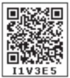
அ. நிழல் உருவாவதை விளக்குகிறது
ஆ. கிடைக்கப் பெறவில்லை
இ. நிழல் உருவாகுவதற்கான காணொளியை காட்டுகிறது
9. இந்தப் படத்தில் உள்ள நிழல்—. சரியான விருப்பத்தை தேர்வு செய்யவும்

அ. ஒளியின் மூலத்தைப்பற்றி கூறுகிறது
ஆ. மரம் பச்சை நிறத்தில் இருப்பதை காட்டுகிறது
இ. நாளின் தோராயமான நேரத்தை முன்னறிவிக்கிறது
ஈ. மரம் ஒரு ஒளிபுகா பொருள் என்பதை உறுதிப்படுத்துகிறது
11. இந்த வரைபடத்தை பற்றிய உங்கள் அனுமானங்களை எழுதவும்
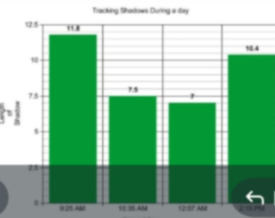
12. —-உள்ளே பிரதிபலிக்கும் போது —----ஒளியை கடத்துகிறது. அ.கண்ணாடி ,அலுமினிய தகடு
ஆ.விமான கண்ணாடி,கண்ணாடி
இ. முப்பரிமாண பெட்டகம் பிளாஸ்டிக்
ஈ.மழைத்துளிகள், காற்று
13. இந்த செயலை செய்த பிறகு என்ன பலன் கிடைக்கும்
Activity 8
14. வகுப்பறையில் பரவிய ஒளியால் நிரம்பி உள்ளது. இது உங்கள் மாணவர்களுக்கு எப்படி விளக்குவது? வகுப்பறையில் ஒழுங்கற்ற எதிரொளிப்பு அடைந்து அறை வெளிச்சம் அடைகிறது. இதை எப்படி உங்கள் மாணவர்களுக்கு விளக்குவீர்கள்?
15. மெழுகுவர்த்தியில் இருந்து வெளிச்சம் பரவி நேர்கோட்டில் இருக்கும்.
இதை வகுப்பறையில் எவ்வாறு கற்பிக்க முடியும்?

ASSESSMENT TOOL- LESSON MAGNETISM STD 7
1.Ways to find if a if a rod is magnetic_–
2.Properties that magnets have other than being magnetic—
3. And unmarked horse shoe magnet without North and South marks is given to you. How will you identify it's north and South pole?
  - Use iron nails
  - use magnetic compass
- can not find
- I don't know
4. Fill up the blank with appropriate answer.
Take a nail a piece of iron and place it on the table. Now take a bar magnet and place one of its poles near one edge of the nail and rub from one end to the other. —---. Repeat the process for 30 to 40 Times
5. What is the proper method of storing two magnets together?
  - Keep them together in a wooden box
- keep a wood between them with like poles facing each other
- keep a wood between them with unlike facing each other
6. Magnetic north pole of the Earth is actually on the southern hemisphere. Explain
7. which of the following magnet will lose its magnetism?
      - Magnets kept in water
- ferromagnets
- magnets coated with oil
- magnet heated to high temperature
8. Magnets lose their properties when they are placed near cell phone, computer, DVDs. These objects will also get affected by magnetic field. But phone covers use magnets. How do you explain this?
9. I bought ring magnets used in Levitating toy from—-. Source for ring magnet is—-.
10. Principles used in electromagnetic train are—-
11. My difficulty in reading and comprehending this lesson is due to—
12. The phenomenon observed in this is--------------

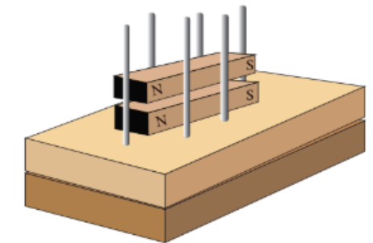
a. Electro magnetism b. Levitation c. Making of a magnet
13. Does this QR code function? What challenges are faced in making this toy?
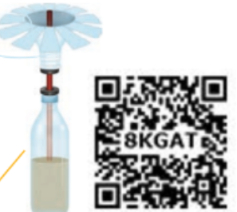
14. 
  - QR code is available
  - URL is available. Opens on one click
  - Only URL is available. Opens on copy and pasting in Google search
15. The language in this QR code is-------------
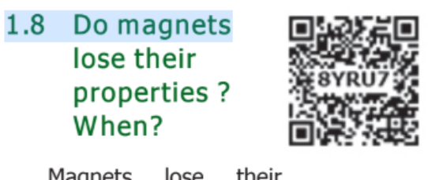
- Tamil
- English
- It does not open

ASSESSMENT TOOL- CROP MANAGEMENT STD 8
1.Paddy is an example for — and — crop
2. Cotton hemp and —are examples of fibre crops
3. What are the functions of plough?
4. Identify the instrument and explain functions
5. Examples for manure are—
6. Give the sequence of soil preparation
7. Cotton sugar and ladies finger can can be sowed by—method
8. Levering of soil should be done for uniform distribution of manure .correct the incorrect sentence
9. Identify the images
10. Which system of irrigation is affected when arid area? support with explanation.
11. Why does weed grow faster than crops?
12. Give the principle in this method of separation and name the process. Winnowing, sieving
13. Paddy sugarcane, black gram are grown one after another in a field. why is it done?
14. Heritage seeds are not consumed. reason
15. Lichen acts as bio indicator. reason.
16. List to the methodology used for teaching all topics in this lesson

ANNEXURE 2
PHOTOS OF EXPERIEMENTS PERFORMED DURING INTERVENTION
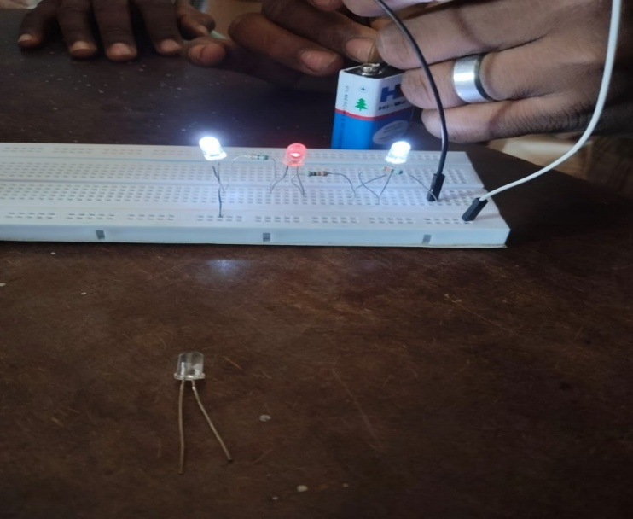 | 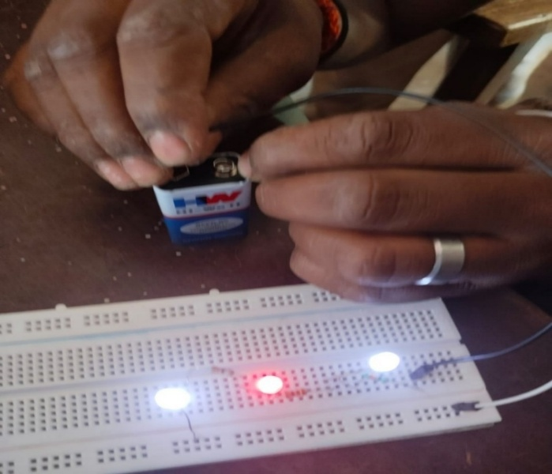
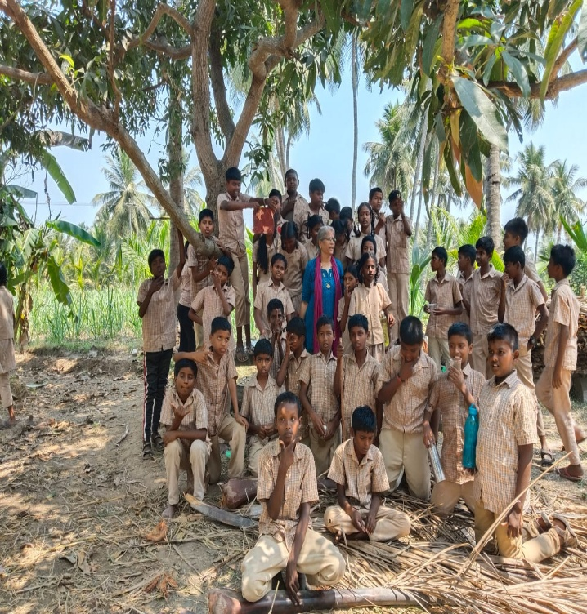 | 